Appendix B: Full, Itemized List of Evidence

Table of Contents
allyable 3
Evidence from Website 3
Evidence from Twitter 4
accessiBe 9
Evidence from Website 9
Evidence from E-mail 12
Evidence from Twitter 12
Evidence from Facebook 13
Evidence from LinkedIn 18
Evidence from Google Ads (source: SpyFu.com) 19
Evidence of other anti-competitive behavior 20
Evidence that accessiBe’s solution does not live up to its promises 21
Accessus.ai 22
Evidence from Website 22
ActiveIntent 27
Evidence from Website 27
AudioEye 28
Evidence from Website 28
Evidence from Twitter 28
Evidence from Google Ads (source: SpyFu.com) 29
EqualWeb 31
Evidence from Website 32
Evidence from Twitter 34
Evidence from Facebook 39
Evidence from Google Ads (source: SpyFu.com) 40
Max Access (by Online ADA) 42
Evidence from Website 42
Evidence from Facebook 44
Evidence from Google Ads (source: SpyFu.com) 45
Purple Lens 47
Evidence from Website 48
UserWay 48
Evidence from Website 49
Evidence from Email 52
Evidence from Twitter 53
Evidence from Facebook 54
Evidence from Google Ads (source: SpyFu.com) 59
Evidence of other anti-competitive behavior 61

allyable
“Allyable creates software to make digital accessibility easier and faster for site owners. Our award-winning technology reduces the cost and complexity typically associated with making websites compliant with accessibility laws and guidelines.” (https://www.facebook.com/allyablesoftware/)

Address: 1410 N 31st St, Philadelphia, PA 19147
Website: https://allyable.com

Evidence from Website
The company claims to “fix” accessibility violations in real time:

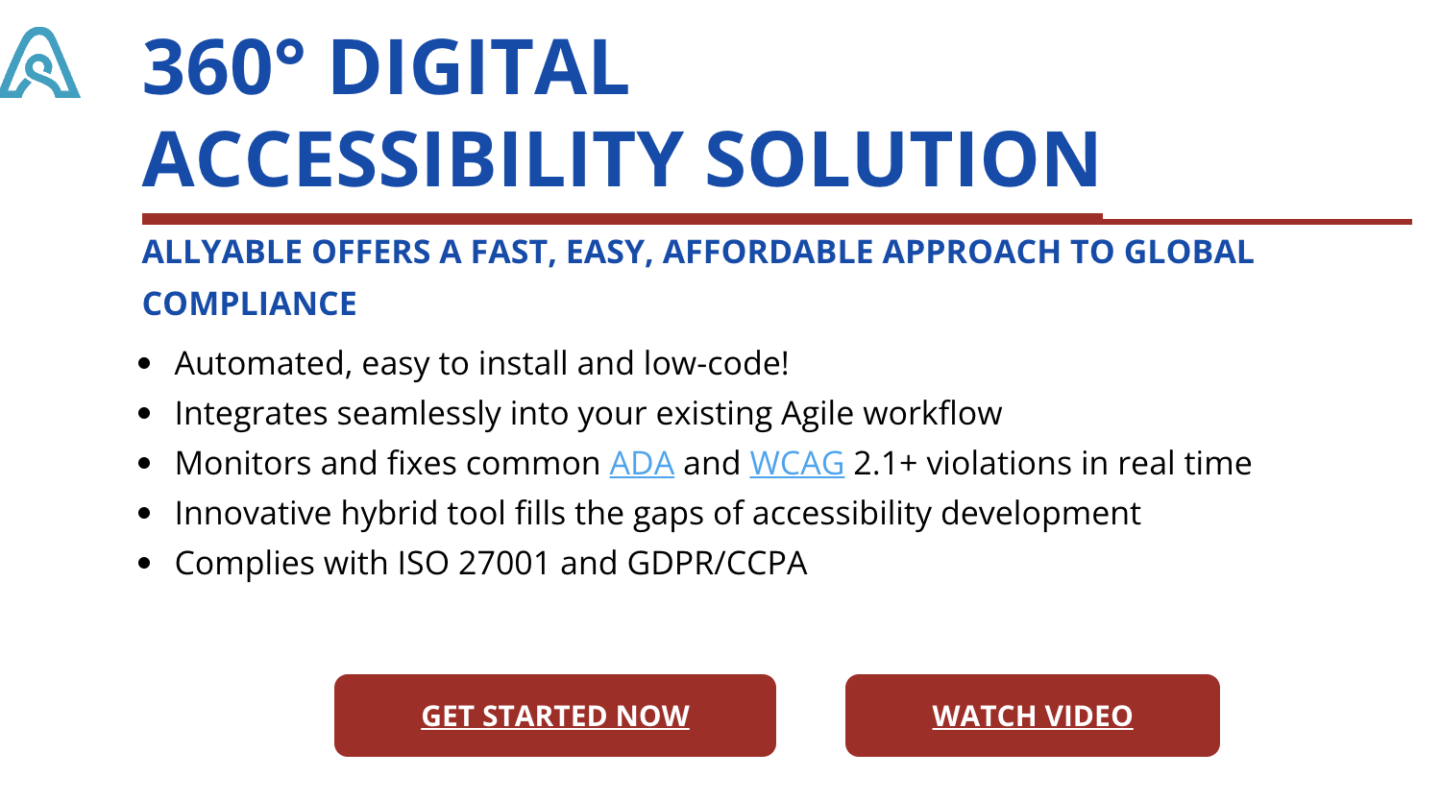
Figure 1: 360° Digital Accessibility Solution (Captured on October 21, 2021)

The company’s FAQ claims that their product offers, “immediate remediation, continuous compliance, and built-in accessibility for existing digital content and assets in development,”:
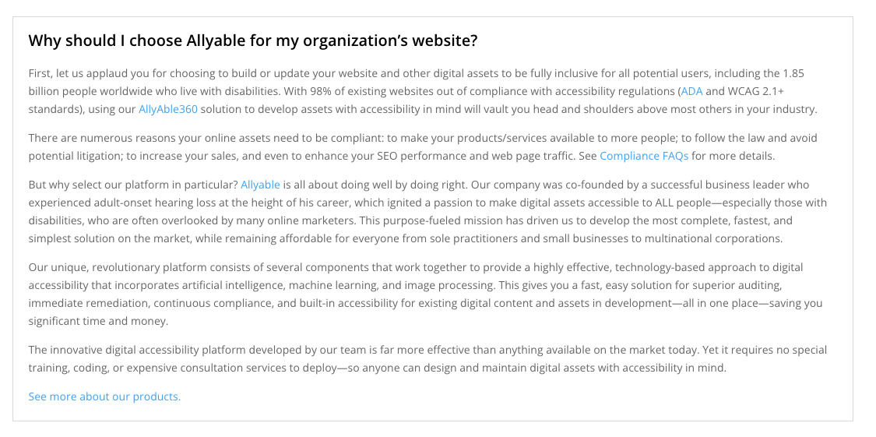
Figure 2:Why should I choose Allyable? (Captured on October 21, 2021)

Allyable claims to be trusted by some big-name clients such as KPMG and Microsoft, but no evidence of this partnership appears to exist on the alleged clients’ web presence, or the company uses another widget (i.e., Olo).

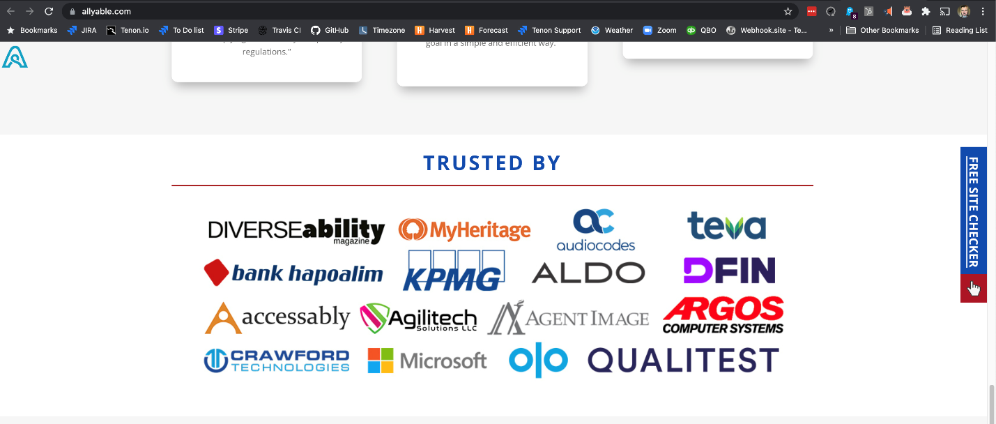
Figure 3: Trusted By (Captured on October 21, 2021)

Evidence from Twitter
https://twitter.com/allyable

On their Twitter profile, allyable claims it is, “[t]he fastest way to reach your digital accessibility goals.” (https://twitter.com/allyable), which is an easy boast when you also claim that you are the “only digital accessibility provider that gives an end-to-end solution”:

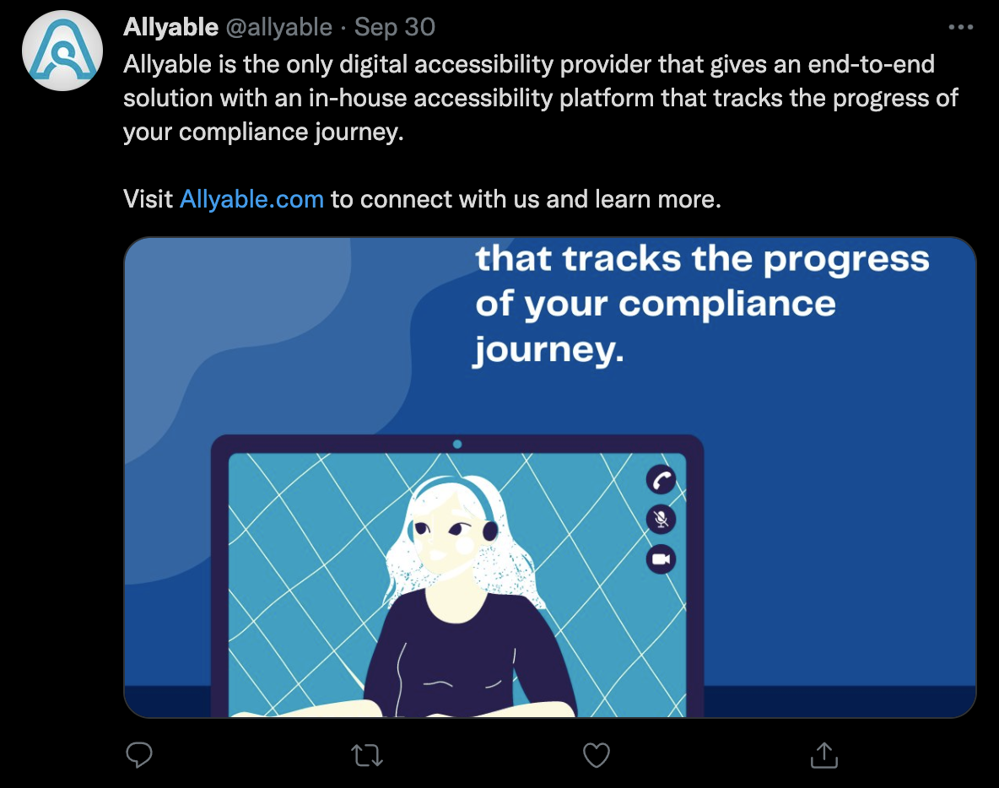
Figure 4 : Allyable is the only digital accessibility provider (Captured on October 21, 2021)
https://twitter.com/allyable/status/1443592062528413704

The company promises the “easiest and fastest solution to make your digital assets ADA compliant”:

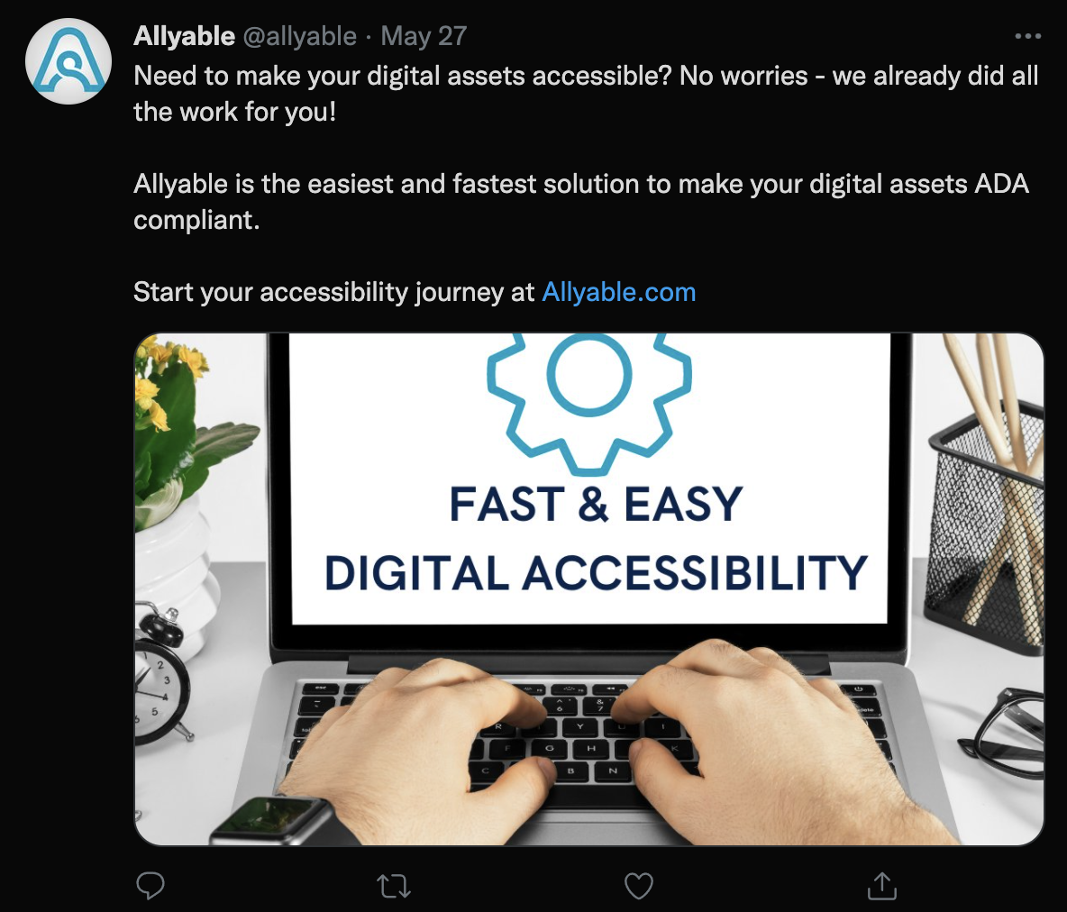
Figure 5: Fast & Easy (Captured on October 21, 2021)
https://twitter.com/allyable/status/1397916050075701250?s=20
In this tweet, Allyable touts that its solution is “truly accessible” and “beyond just a toolbar”:
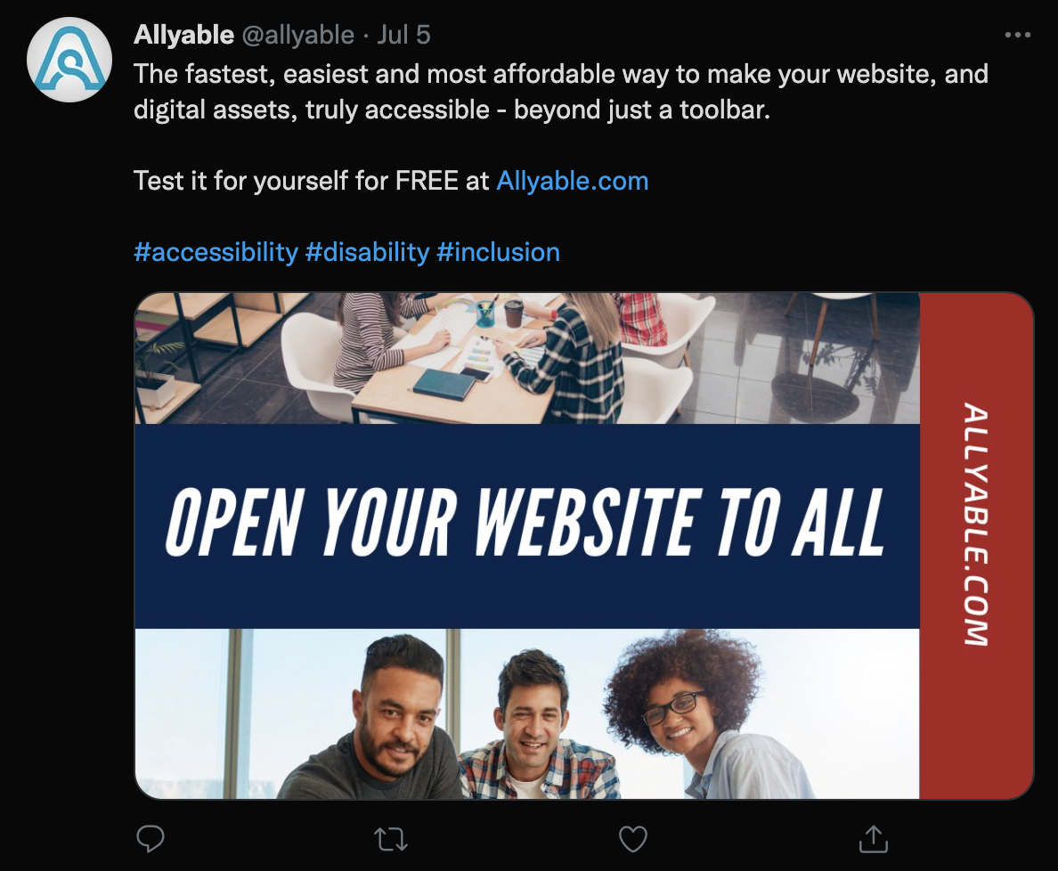
Figure 6: Open Your Website to All (Captured October 21, 2021)
https://twitter.com/allyable/status/1412090355277877259?s=20

Finally, the company promises that its AllyFix™ product uses “advanced AI…to consistently correct most identified eros [sic] automatically”:

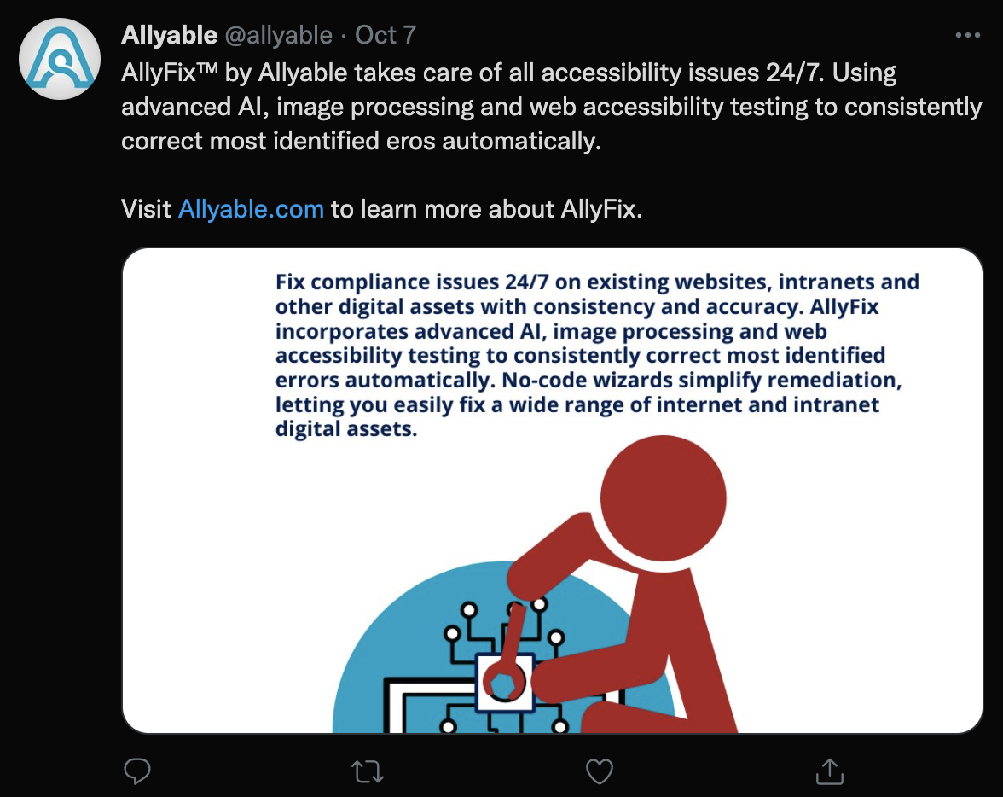
Figure 7: AllyFix (Captured October 21, 2021)
https://twitter.com/allyable/status/1446129081863471104?s=20

accessiBe
Address: 6 Hachilazon, RAMAT GAN, 5252270 Israel
Website: http://accessibe.com

“By using AI and automation, we can make thousands of websites accessible in the amount of time it used to make just one - and at a fraction of the cost. Our AI is taught to go beyond basic requirements and create an exceptional digital experience for people with disabilities.” (https://accessibe.com/company)

Evidence from Website
The claims begin before the fold, so to speak, as one visits the accessiBe homepage, with claims of a “2-minute installation for 24/7 automatic accessibility”:

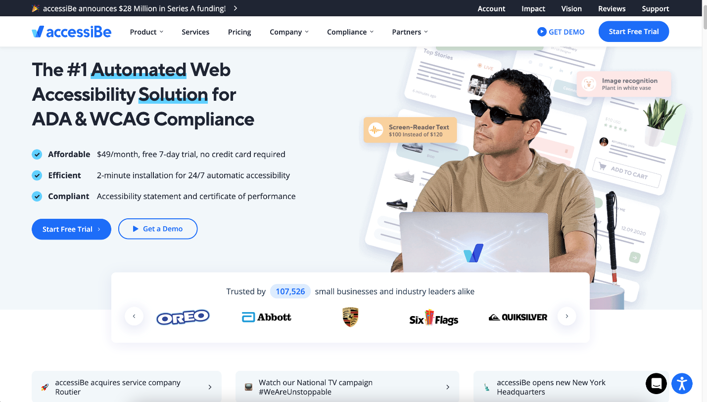
Figure 8: accessiBe Homepage (Captured on October 20, 2021)

The company’s website makes strong claims that their product will almost magically make any website accessible with only “a single line of JavaScript code”:

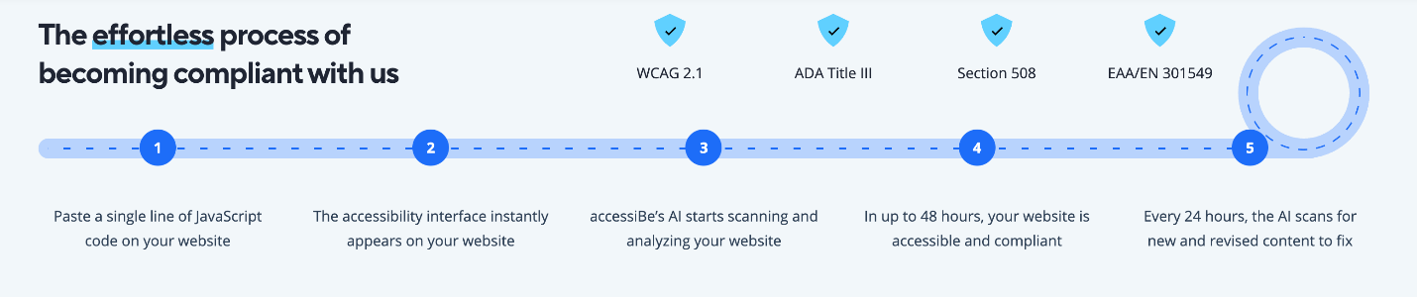
Figure 9: The effortless process (captured October 16, 2022)

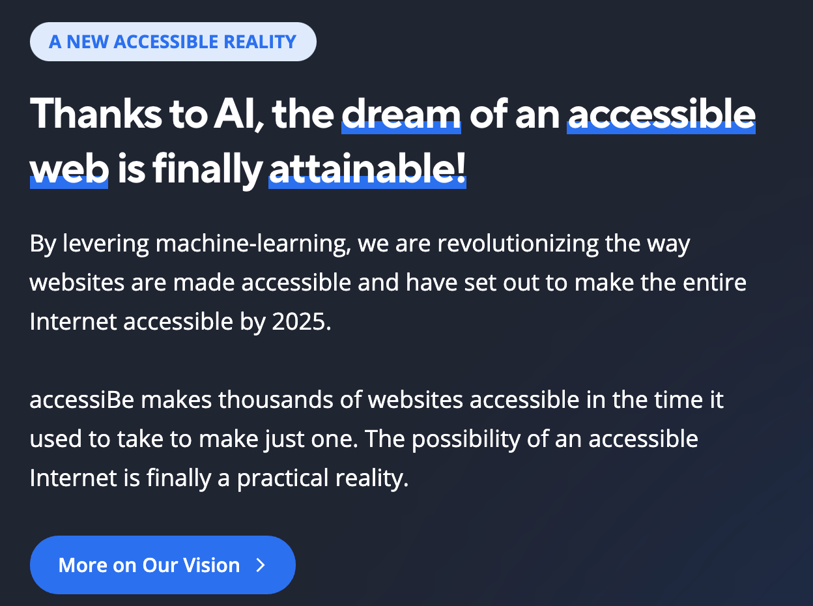
Figure 10: A New Accessible Reality (captured on October 16, 2021)

And (in our opinion), the most egregious claim is about using accessiBe can “stop any lawsuit in its tracks.” :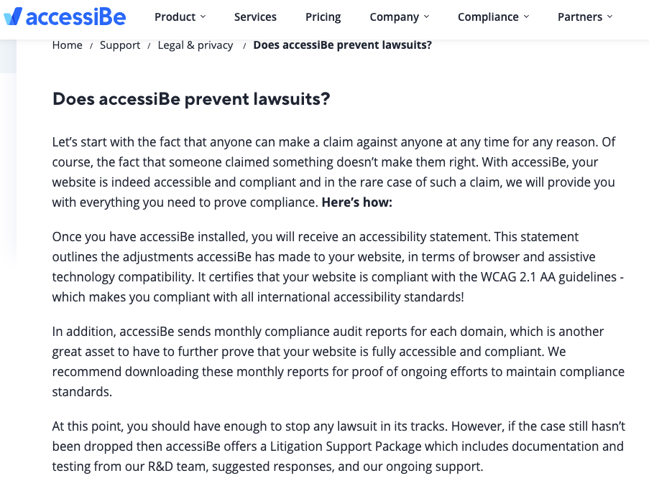
Figure 11: Does accessiBe prevent lawsuits? (Captured on October 18, 2021)

Evidence from E-mail
The following is a marketing email from accessiBe received on March 23, 2021, wherein they claim to “remediate websites according to ADA and WCAG guidelines…within 48 hours.”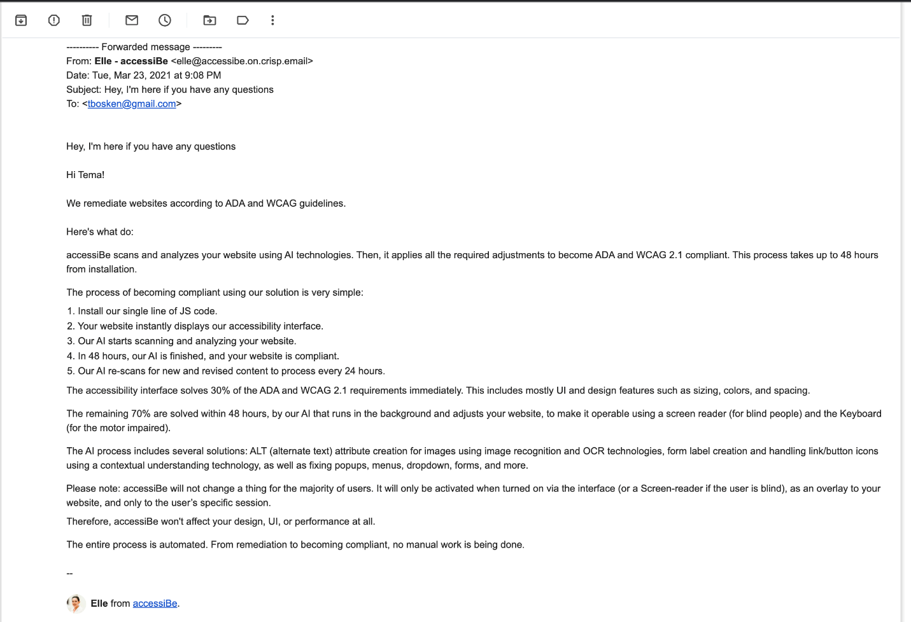
Figure 12: Marketing email from accessiBe (received on March 23, 2021)

Evidence from Twitter
https://twitter.com/accessibe
The company’s tweets often boast about how they can “make websites #ADA compliant”:
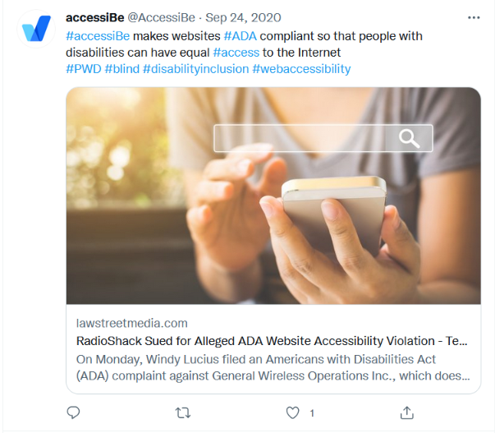
Figure 13: accessiBe makes websites ADA compliant (Captured on October 24, 2021) https://twitter.com/AccessiBe/status/1309123843995377673

Evidence from Facebook
https://www.facebook.com/accessibe

The company also actively uses Facebook as a marketing tool, often touting its ability to allow websites to “meet ADA compliance without spending an arm and a leg”:

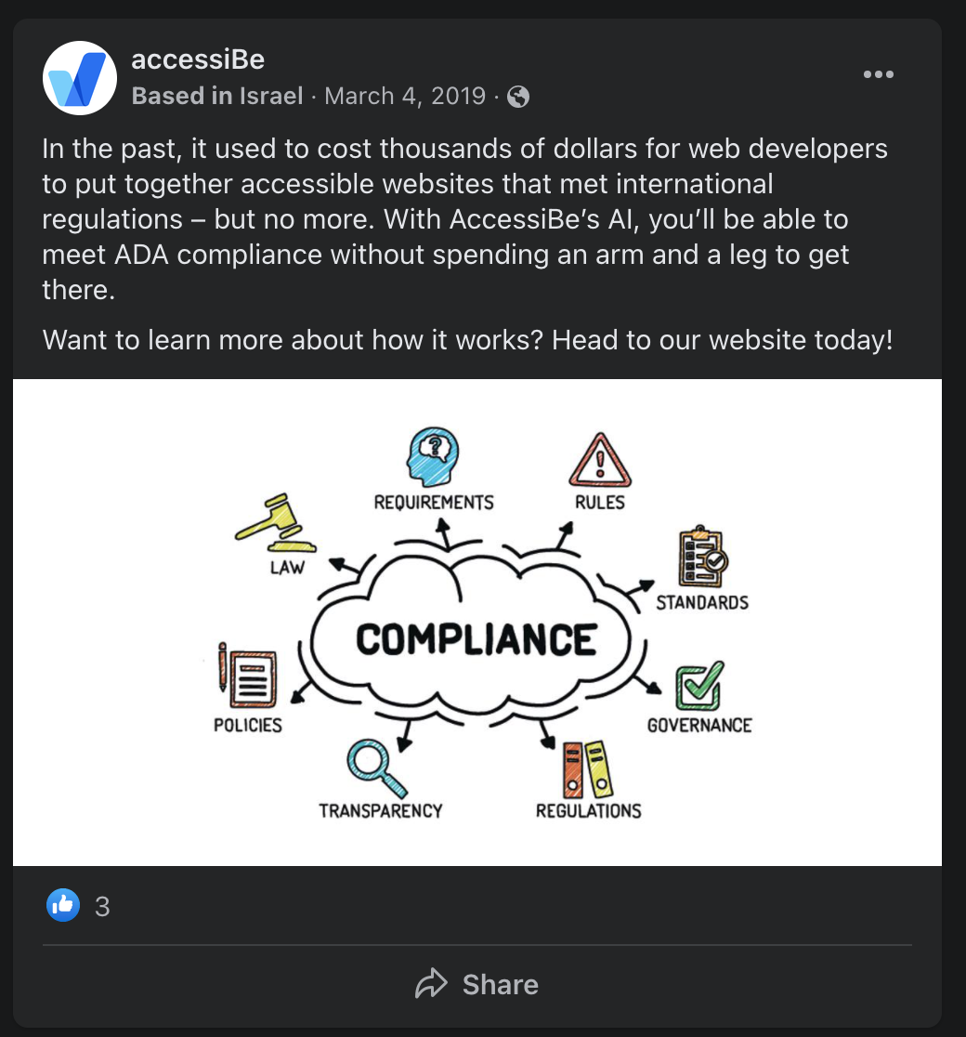
Figure 14: In the past… (https://www.facebook.com/accessibe/posts/1156399274547046)

The company also likes to publicize its how AI is “a better way” than manually fixing errors:

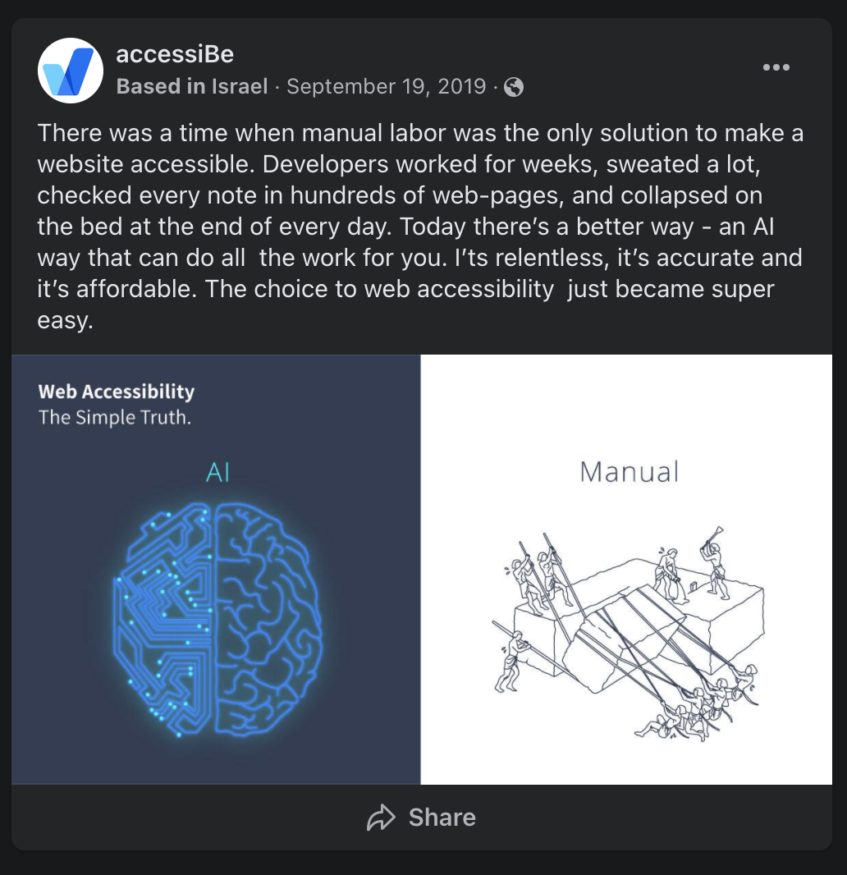
Figure 15: Manual Labor (https://www.facebook.com/accessibe/photos/a.1070584513128523/1314238058763166)

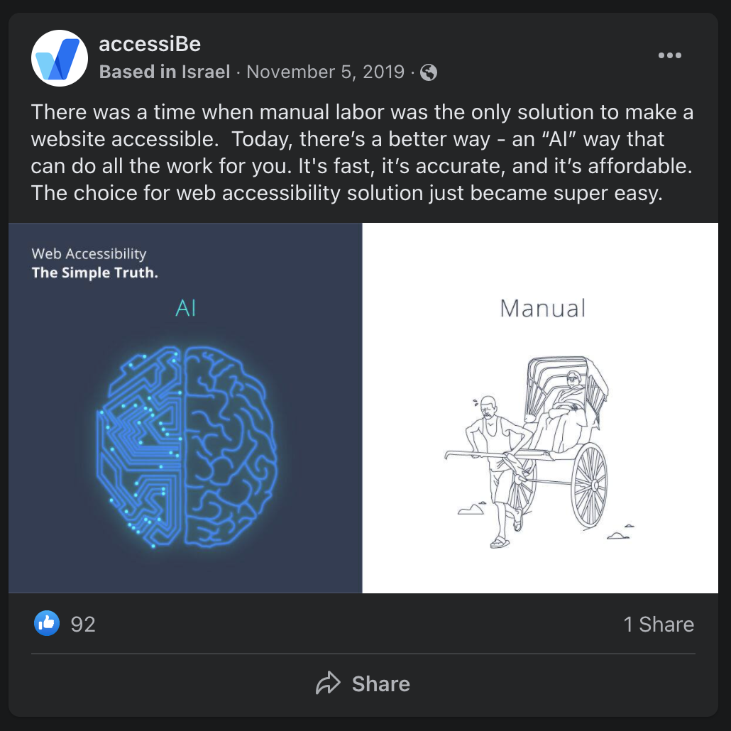
Figure 16: Manual Labor 2 (https://www.facebook.com/accessibe/photos/a.1070584513128523/1364497460403892/?type=3)

Facebook is also a place where they post videos declaring how their solution “solves web accessibility issues on every website”:

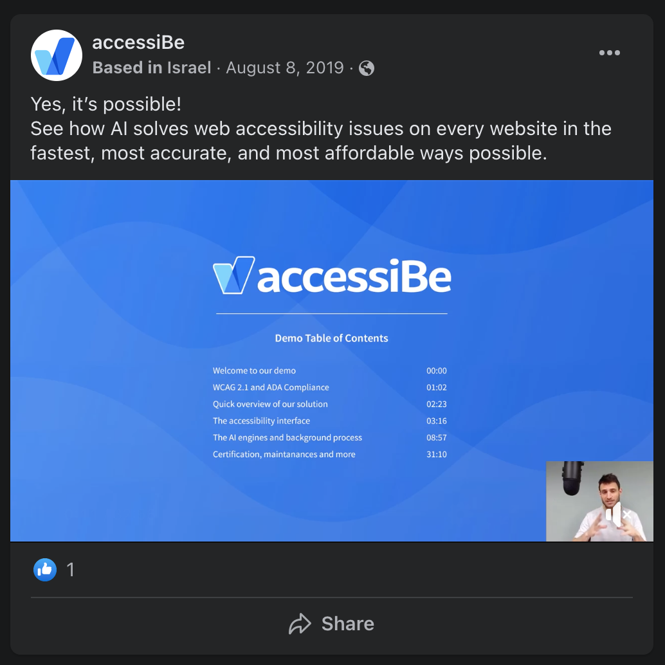
Figure 17: Yes, it’s possible! video (https://fb.watch/8U59pVdrlc/)

Finally, we find this example to be the most gauche, as it preys on a fear of people with disabilities:
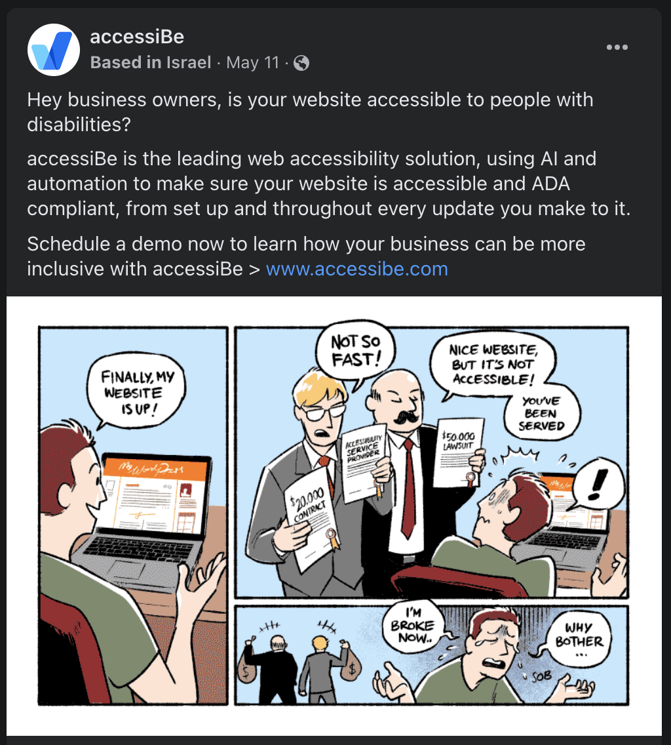
Figure 18: Hey Business Owners (https://www.facebook.com/accessibe/posts/1948500805336885)

Evidence from LinkedIn
https://www.linkedin.com/company/accessibe/
In a comment on LinkedIn, CEO Shir Ekerling claimed that no company has ever been sued because of accessiBe. That may have been correct at the time of the post, but as we’ve shown, that’s not true anymore:
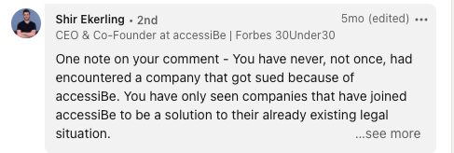
Figure 19: LinkedIn comment from Shir Ekerling

Evidence from Google Ads (source: SpyFu.com)
accessiBe spends an estimated $16,531 on CPC ads per month.
40% of the accessiBe website traffic comes from CPC ads

The company’s advertising on Google suggests one can avoid being sued by using their product:

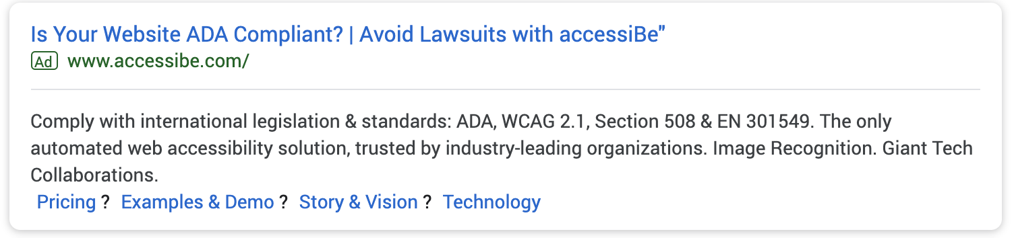
Figure 20: Is Your Website ADA Compliant Google Ad (captured January 1, 2020)

Evidence of other anti-competitive behavior
When using an automated accessibility tool such as WAVE, accessiBe’s overlay blocks a proper scan of the site:

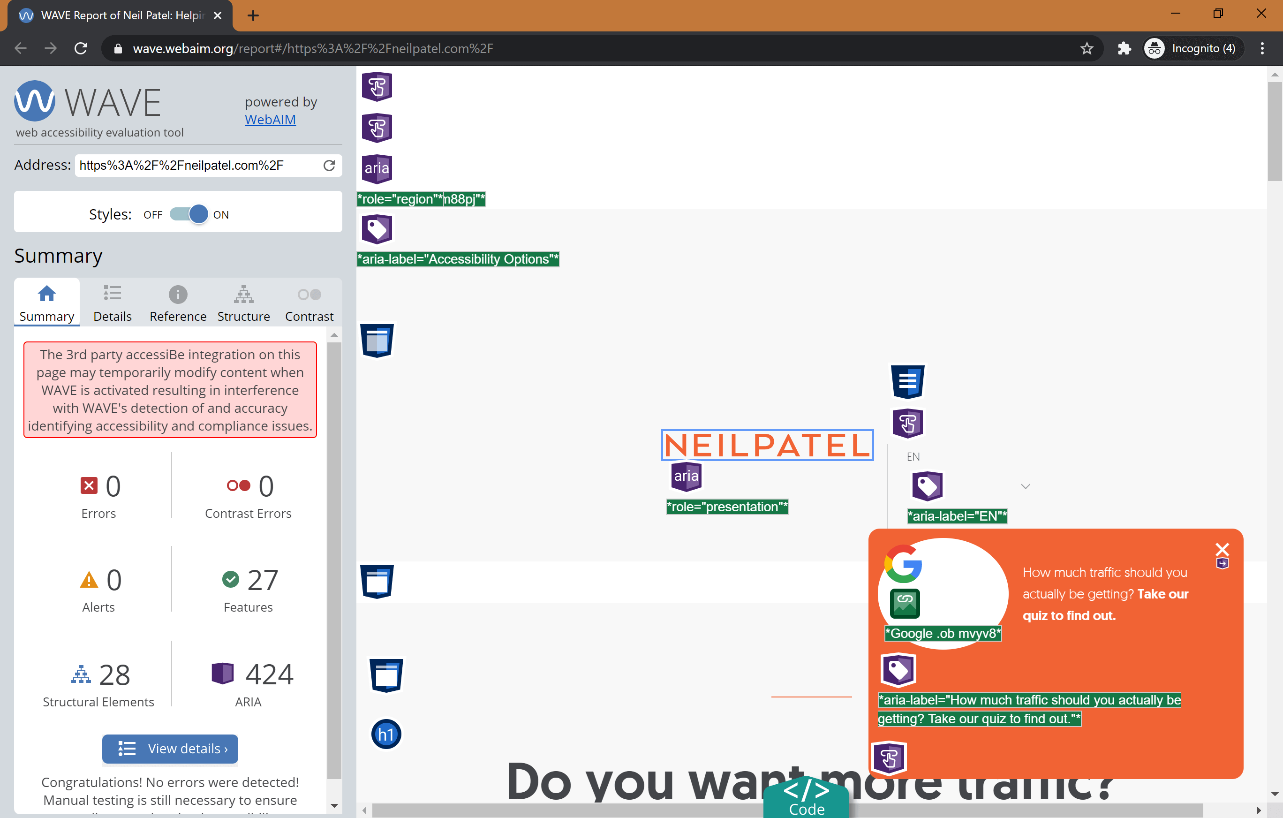
Figure 21: accessiBe Blocks Automated Scans

Evidence that accessiBe’s solution does not live up to its promises
The captions that accessiBe automatically generates are poor even by auto-caption standards. The audio for the below was, “…collaborated with lead developers from the JAWS team…”:

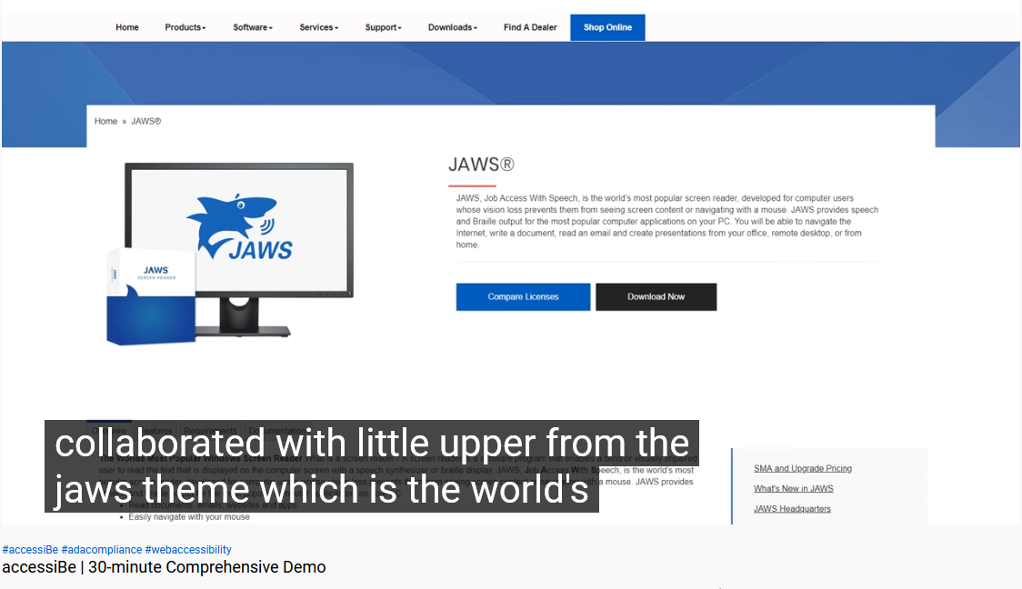
Figure 22: accessiBe's Auto Captions Fail

Accessus.ai
Address: 102 West Pennsylvania Avenue Suite 401, Towson, MD 21204, United States
Website: https://accessus.ai/

“The Accessus.ai mission is to contribute towards making the entire internet completely accessible so that everyone, with or without disabilities, can enjoy the universe of content it has to offer.

In today's legal environment, ALL businesses are now challenged with meeting the current technical and compliance standards in addition to the potential threat of expensive litigation defense and settlement costs.

The Accessus.ai solution is designed with your complete technical and legal situation taken into consideration on a long-term basis.”
(https://accessus.ai/about)

Evidence from Website
The company promises “Fully Automated WCAG 2.1 AA Compliance” in “less than 48 hours”:

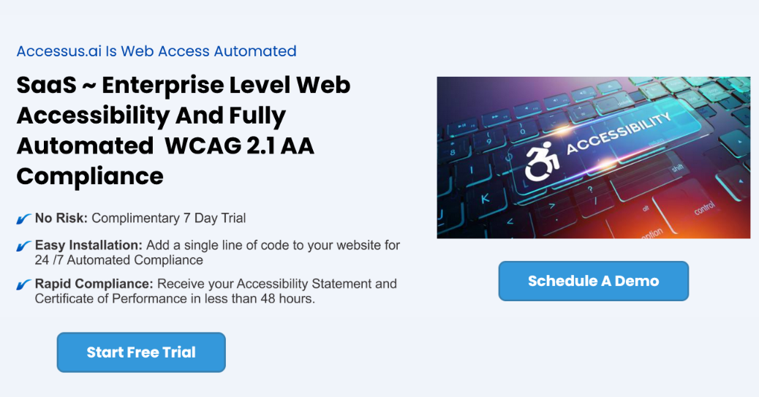
Figure 23: Accessus.ai is Web Access Automated (Captured October 27, 2021)

When one schedules a demo, they are told once again that compliance can be achieved in “less than 48 hours” using the company’s “Artificial Intelligence”:
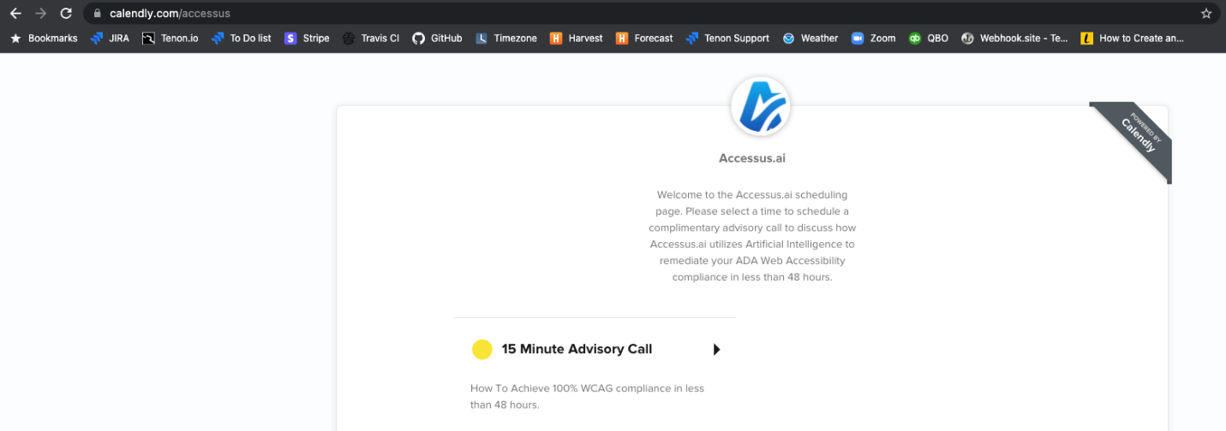
Figure 24: Schedule a 15 Minute Advisory Call

In addition to the familiar claims of “a single line of JavaScript code” to achieve “fully compliant and certified” status, Accessus.ai takes the low road by throwing some of its named clients (e.g., AudioEye, User1st, UserWay, WP Access) under the proverbial bus, claiming they cannot deliver the same scope of compliance (e.g., WCAG 2.1, ADA, s508) in a similar 48-hour time frame. They also claim that their solution has the “[i]ndustry highest success rate” while others only meet 5% to 50% of the requirements within 6 months without providing a source for this data:

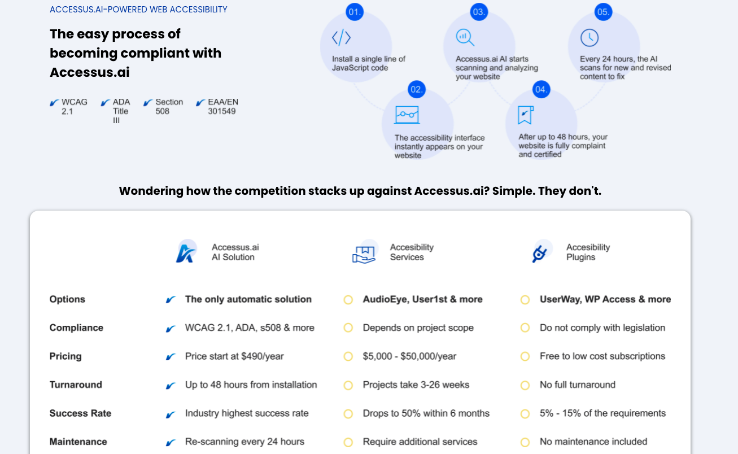
Figure 25: Accessus.ai-powered web accessibility

Much like other overlay companies, Accessus claims that its product can “[p]rotect and defend” against “costlylitigation[sic]”:
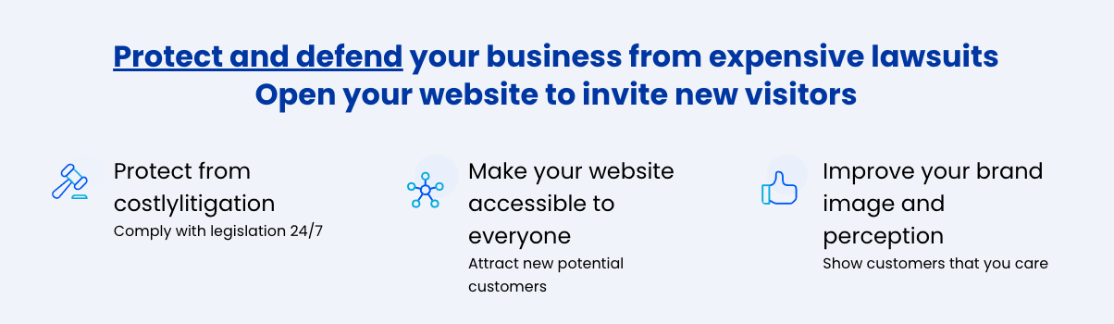
Figure 26: Protect and Defend

The company’s answer to how they provide protection from litigation makes the same bold and spurious claims as many of its competitors, including offering a worthless “Certificate of Performance”:

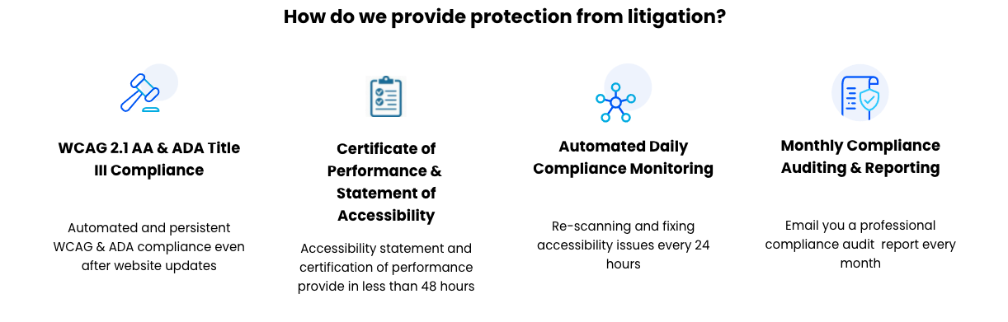
Figure 27: How Accessus provides protection from litigation

The company claims that their solution “provide[s] and maintain[s] 100% WCAG compliance standards.”
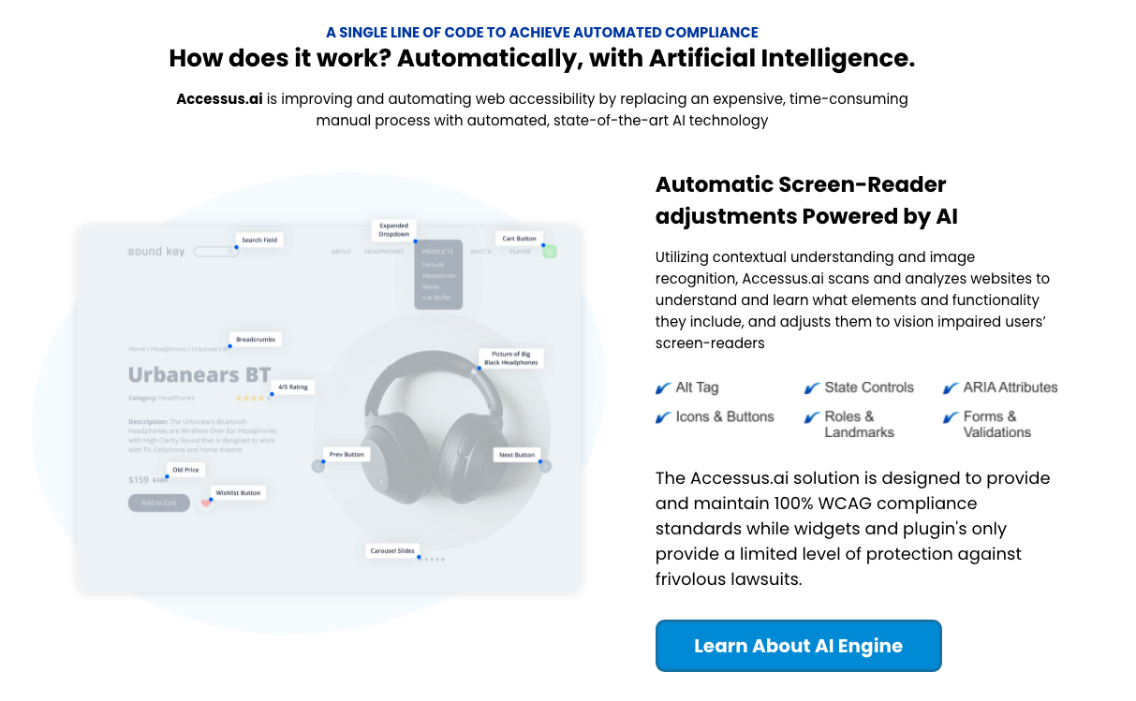
Figure 28: How does it work? (Captured October 27, 2021)

Relatively unique among their peers, Accessus.ai also claims that their solution can offer CCPA and GDPR Compliance:
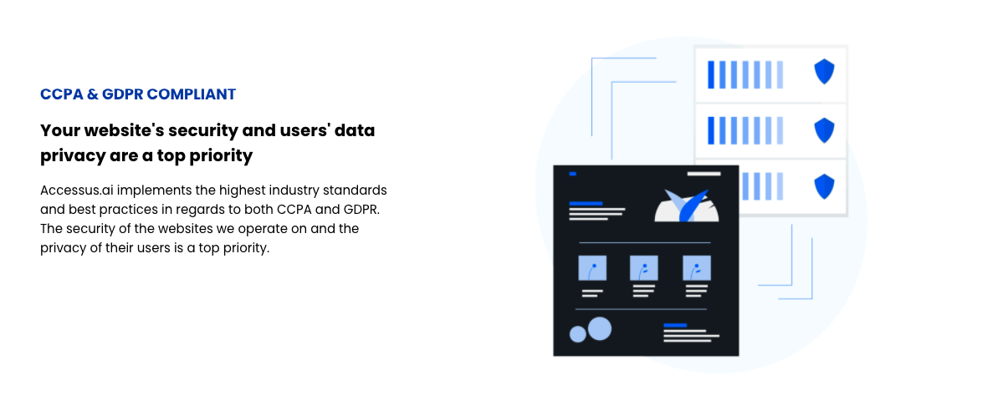
Figure 29: CCPA & GDPR Compliance
The company claims that their product will protect their customers from accessibility-related litigation and that the product covers all (emphasis mine) WCAG 2.1 AA (and some AAA) guidelines:
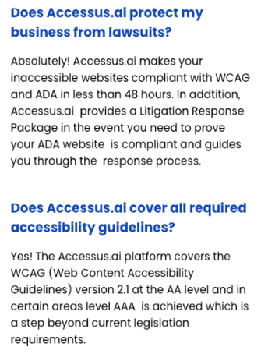
Figure 30: Accessus.ai FAQ (Captured October 20, 2021)

ActiveIntent
Website: https://theactiveintent.com/

Active Intent makes your website voice activated on mobile and desktop.
Users can click on the generated microphone icon and start conversationally interacting with your website. (https://theactiveintent.com/)

Evidence from Website
The company claims that voice activated websites, “ensure American with Disabilities Act compliance.”
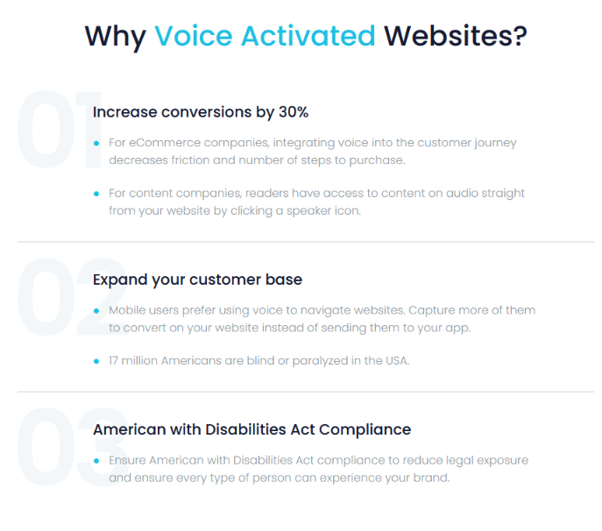
Figure 31: Why Voice Activated Websites (captured on October 27, 2021)

AudioEye
Address: 5210 E Williams Circle, Suite 750, Tucson, Arizona 85711, US
Website: https://www.audioeye.com/

“AudioEye’s industry-defining digital accessibility platform delivers website compliance efficiently and affordably for organizations of all sizes. Our platform leverages a decade of investment in advanced technology supported and informed by our team of dedicated IAAP-certified professionals to help deliver improved access to the web.” (https://www.audioeye.com/about-us)

Evidence from Website
AudioEye claims several high- profile customers, at least one of whom, WebMD does not reciprocate the claim on their respective websites:

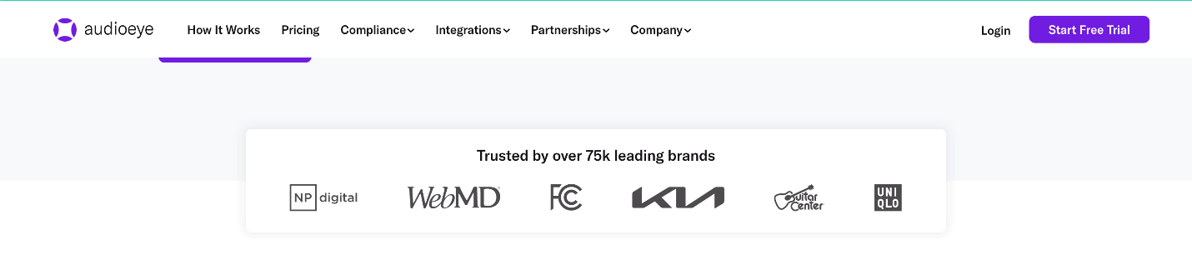
Figure 32: Trusted by over 75k leading brands

Evidence from Twitter
https://twitter.com/audioeyeinc

The company claims its product will, “get you compliant on day one.”
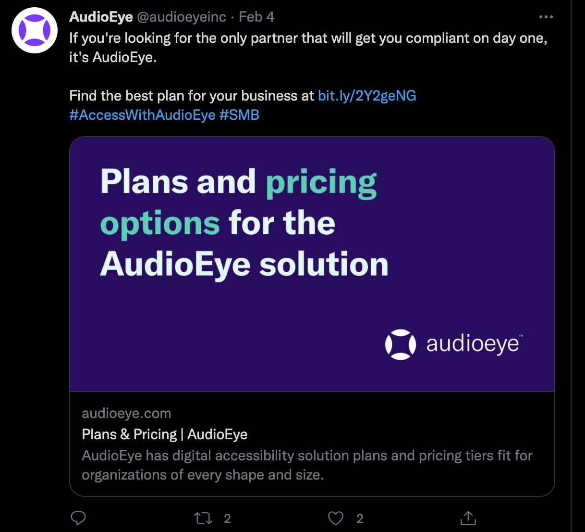
Figure 33: Find the best plan (Captured October 21, 2021)
https://twitter.com/audioeyeinc/status/1357340661041623044?s=20

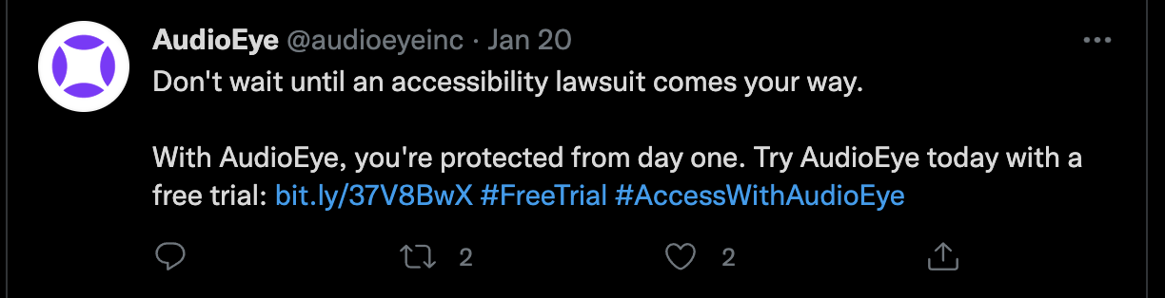
Figure 34: Protected from Day One (Captured October 21, 2021)
https://twitter.com/audioeyeinc/status/1351955182326841346

Evidence from Google Ads (source: SpyFu.com)
AudioEye spends an estimated $24,786 on CPC ads per month.
62% of the AudioEye website traffic comes from CPC ads.

The company Google Ads make promises of compliance with accessibility laws and standards “on Day 1.”
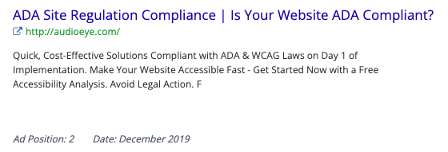
Figure 35: ADA Site Regulation Compliance (Captured by Spyfu in December 2019)

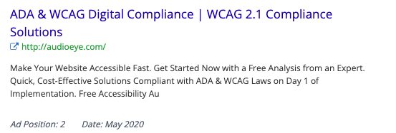
Figure 36: ADA & WCAG Digital Compliance
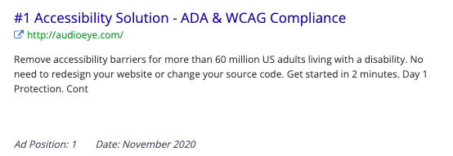
Figure 37: ADA & WCAG Compliance

Some of the company’s ads use the scare tactic of an impending lawsuit and suggest one not “wait to be served”:

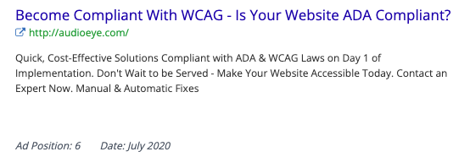
Figure 38: Become Compliant with WCAG
AudioEye also offers “Certified ADA Compliance” even though such a certification does not exist:
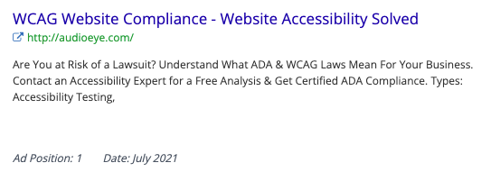
Figure 39: Website Accessibility Solved

Finally, like many of its competitors, the company claims to be the only solution out there:
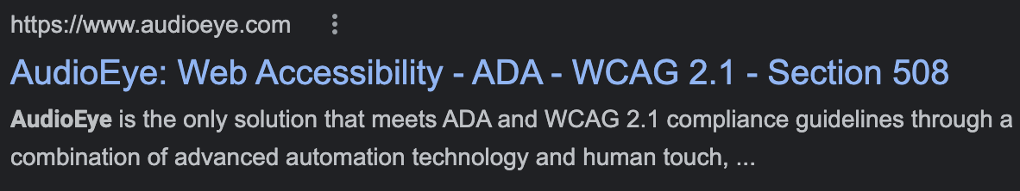
Figure 40: AudioEye is the only solution

EqualWeb
Address: 447 Broadway, 2nd FL #239 New York, NY 10013
Website: https://www.equalweb.com/

“EqualWeb is a development company that specializes in accessibility and advanced internet applications.

With more than two decades of experience, working closely with the blind and disabled, we have gained the confidence and support of many global customers. Our inspired and highly-experienced team of IT, accessibility experts, designers, programmers, and marketing experts are committed to one common goal - effectively offering an accessibility solution for your websites via an extremely simple and cost-effective process.” (http://www.equalweb.com)

Evidence from Website
The company claims its widget “provides full ADA and WCAG 2.1 compliance” with, “no code changes required.”
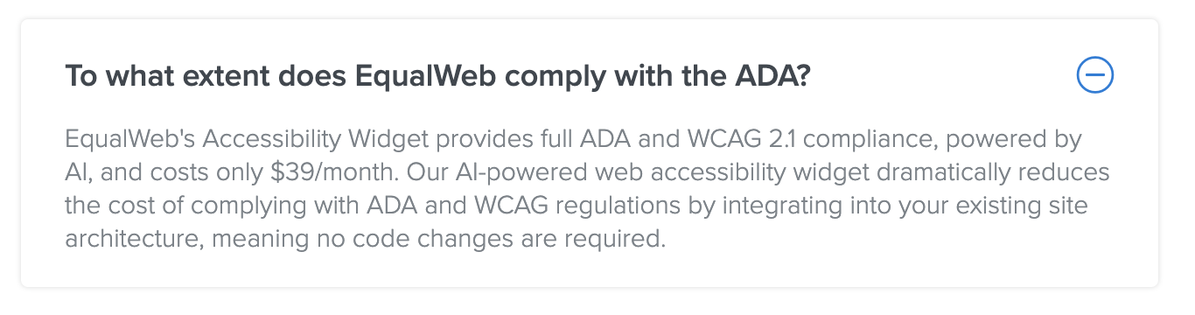
Figure 41: To what extent does EqualWeb comply with the ADA? (Captured October 24, 2021)

EqualWeb claims its solution is “over 100 million web pages” and that they provide their clients with “1,00,000$ [sic] in digital accessibility warranty”: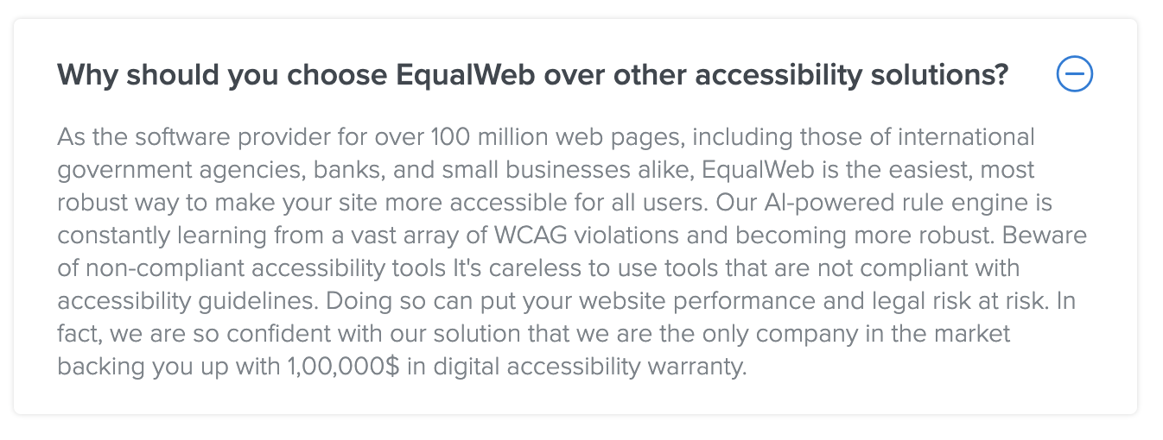
Figure 42: Why should you choose EqualWeb…? (Captured October 24, 2021)
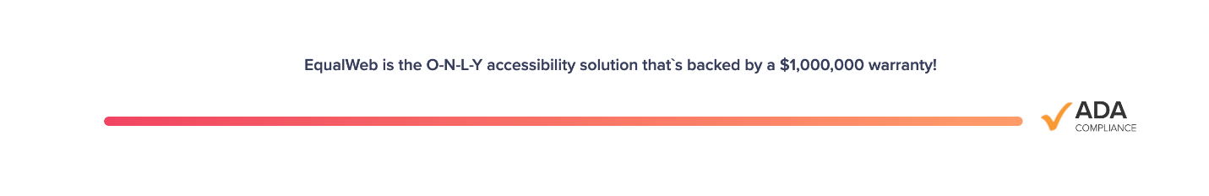
Figure 43: $1,000,000 warranty (Captured October 24, 2021)
Instead of providing names of its marquee clients, the company claims that their solution is installed on over 100 million web pages in a bogus attempt to conflate pages with clients and confuse prospective customers about its market penetration:

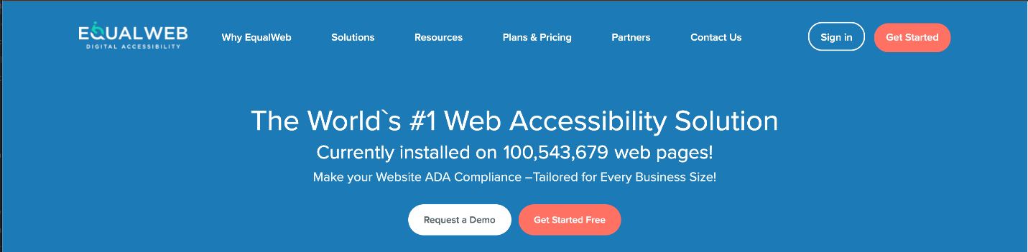
Figure 44: Currently installed on 100,543,679 web pages (Captured on October 24, 2021)

EqualWeb maintains that, aside from it’s supposed unique $1,000,000 warranty, it also uniquely provides compliance with accessibility standards while “all others” only promise a portion of that compliance goal and that “all others” do not offer on-going maintenance:

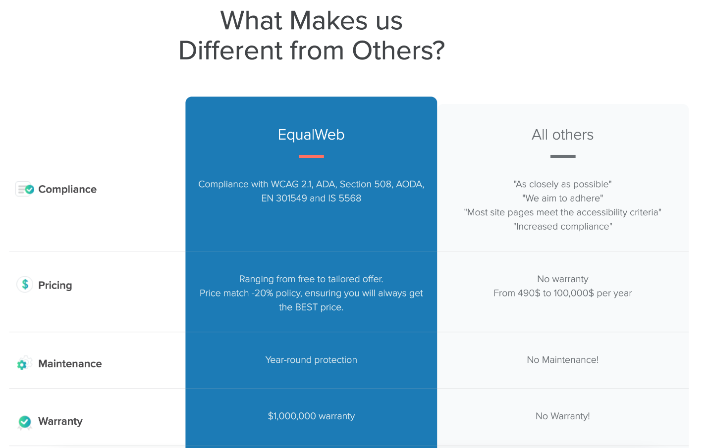

Figure 45: What Makes EqualWeb Different (Captured on October 24, 2021)

Evidence from Twitter
Out of the proverbial gate, EqualWeb touts its solution as “instantly applicable” that meets “International Accessibility Standards”:

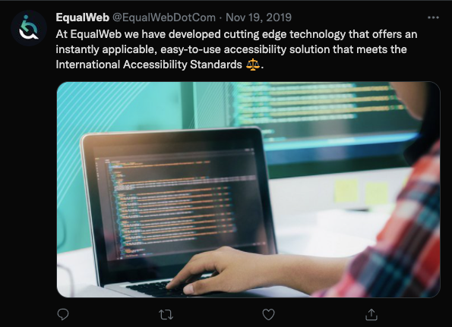
Figure 46: Instantly Applicable
https://twitter.com/EqualWebDotCom/status/1196812164964724737

EqualWeb claims that its widget will “automatically adjust” a website to fix keyboard navigation issues:
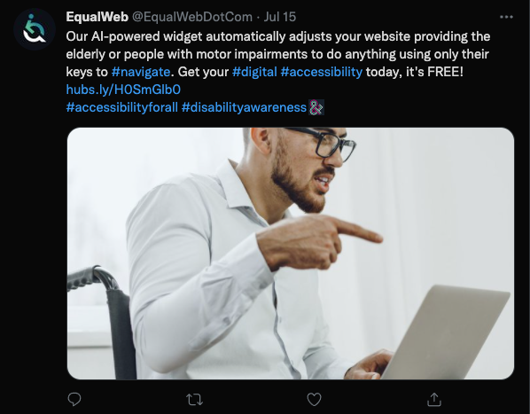
Figure 47: Only Their Keys to #navigate

In this tweet, the company makes the claim that 20 years of experience specializing in web accessibility has allowed them to offer a “simple and cost-effective solution,” suggesting that they’ve been offering an overlay widget for that length of time:
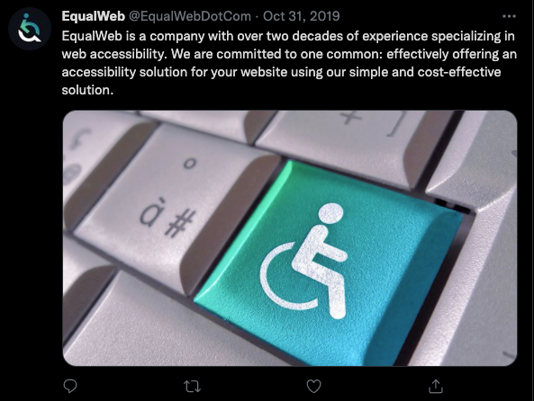
Figure 48: Two Decades of Experience
https://twitter.com/EqualWebDotCom/status/1189888468534616064

By way of promising increased traffic to one’s website, EqualWeb claims to offer “100% ADA WCAG 2.1 AA” compliance. Curiously, they do not give a link in this tweet but instruct the user to go all the way back to the bio on their Twitter account to access a link:
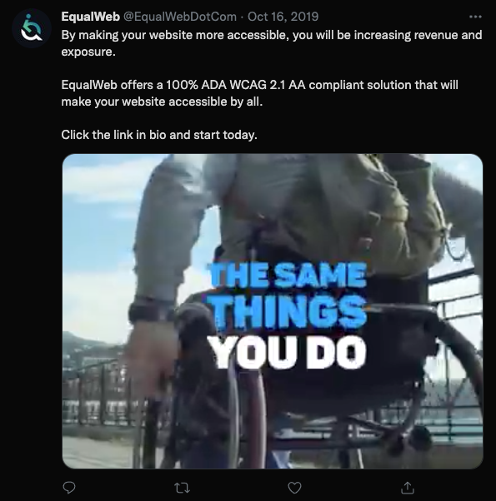
Figure 49: Increase Revenue and Exposure
https://twitter.com/EqualWebDotCom/status/1184555355885522951
The company claims that its “AI-powered accessibility solution” will assist in gaining brand recognition:

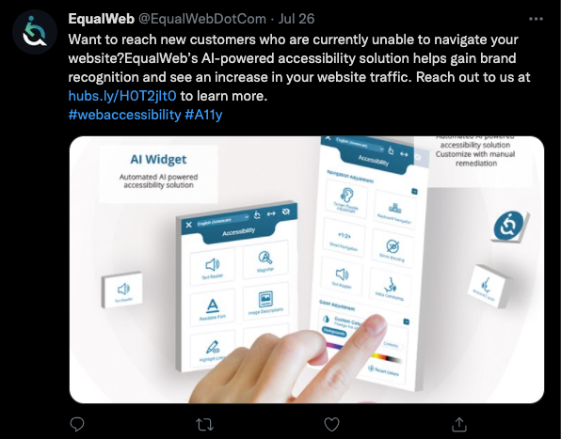
Figure 50: Brand Recognition
https://twitter.com/EqualWebDotCom/status/1419618973860171781
In this tweet, the company talks up its “premium #accessibility solution” that offers a “fully compliant” website as way to bring up its alleged $1 million warranty:

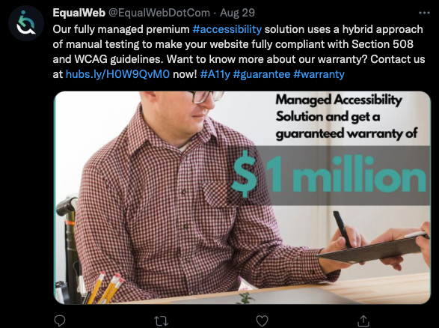
Figure 51: Hybrid Approach
https://twitter.com/EqualWebDotCom/status/1431943453169045504

Evidence from Facebook
https://www.facebook.com/EqualWebDotCom

In the About section of their Facebook page, EqualWeb claims it provides “digital accessibility solutions making websites 100% compliant”:

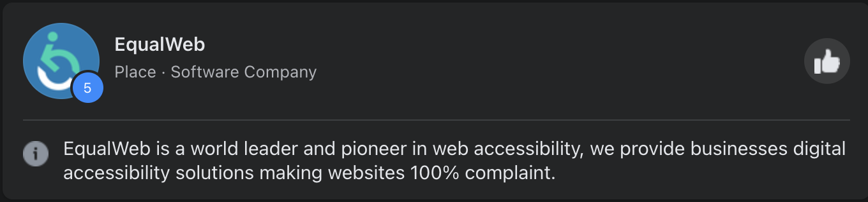
Figure 52: EqualWeb Facebook (Captured on October 27, 2021)

Evidence from Google Ads (source: SpyFu.com)
EqualWeb spends an estimated $4239 on CPC ads per month.
22% of the EqualWeb website traffic comes from CPC ads

As with many of their peers, EqualWeb uses scare tactics in their marketing by saying that their solution will help their customers “avoid lawsuits”:

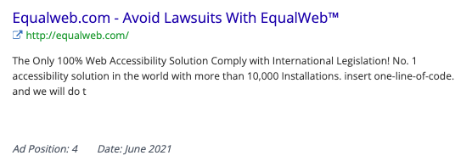
Figure 53: Avoid Lawsuits with EqualWeb™

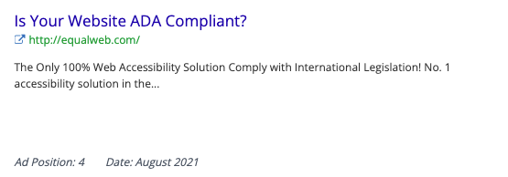
Figure 53: Is Your Website ADA Compliant?
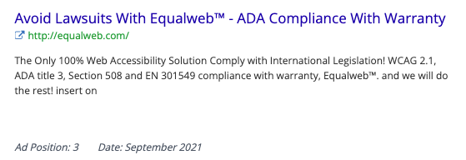
Figure 54: ADA Compliance With Warranty

The company also uses Google Ads to claim it is the “Only 100% Web Accessibility Solution” with “more than 10,000 installations”:

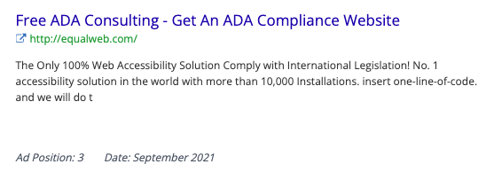
Figure 55: Free ADA Consulting

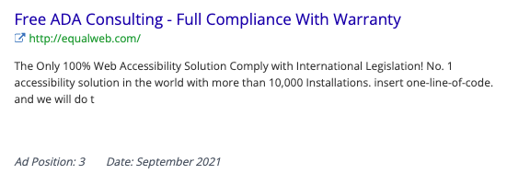
Figure 56: Full Compliance With Warranty

Max Access (by Online ADA)
Address: 207 E 5th Ave. Ste 240, Eugene, OR 97401
Website: https://maxaccess.io/

“Since 2014 Online ADA has been the leading innovator in digital accessibility, providing the highest quality tools for developers to make the internet accessible to everyone.

After years of constant innovation and development we bring you the most elegant and robust solution for digital accessibility.

– Max Access – “
(https://maxaccess.io/story-vision/)

Evidence from Website
On their website, Max Access claims it can get a website “accessible in minutes and…will stay accessible even as you add new content”:
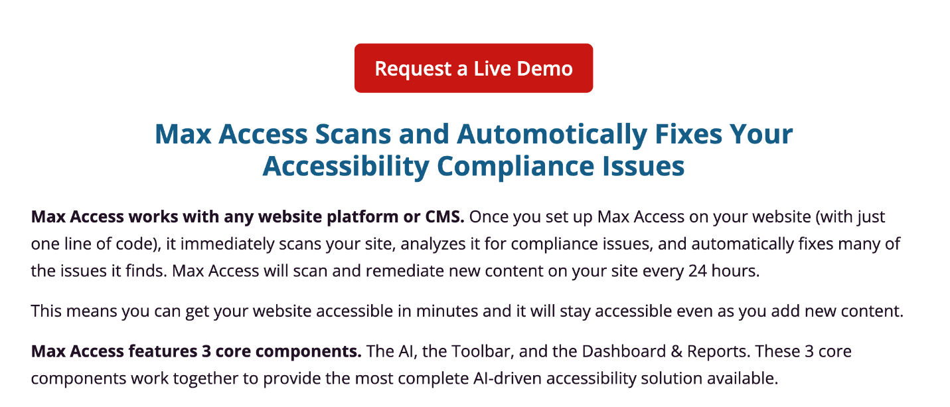
Figure 57: Max Access Scans and Automatically Fixes Your Accessibility Compliance Issues (Captured October 25, 2021)

The company’s website offers “automatic code fixes” and a “WCAG/AODA/ADA/Section 508 Compliant” solution:
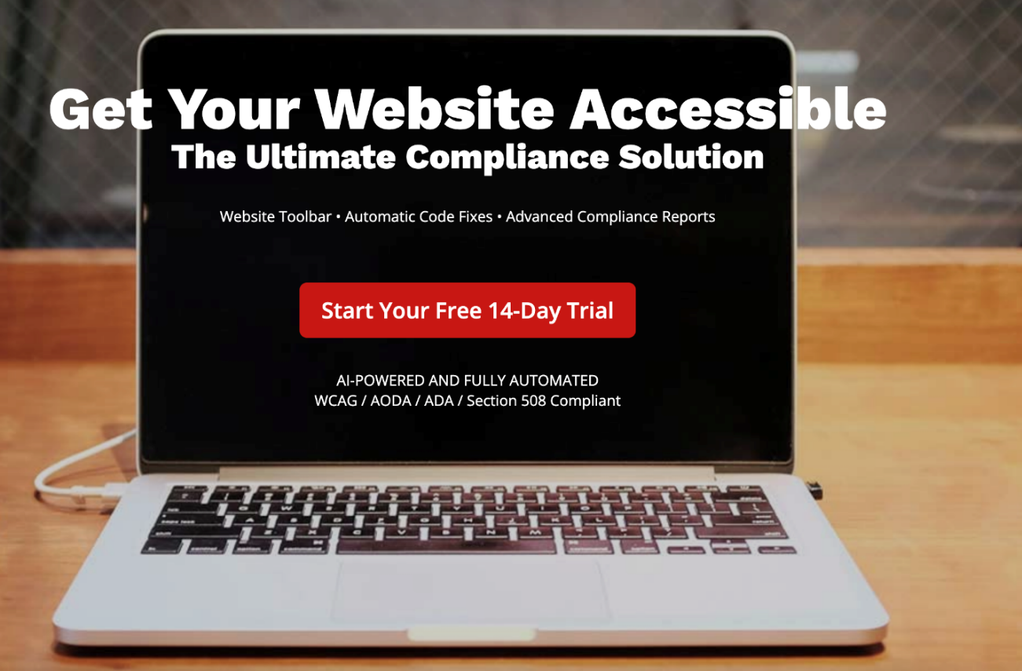
Figure 58: Get Your Website Accessible (Captured October 21, 2021)

The company’s website also engages in some scare tactics claiming that their product can help a client avoid lawsuits and “Maintain the Highest Level of Compliance 24/7”:

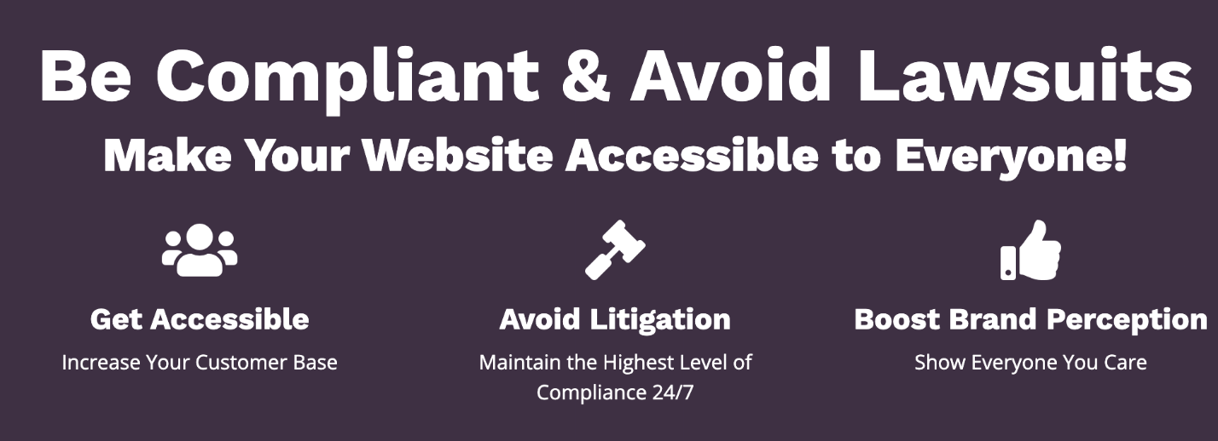
Figure 59: Be Compliant & Avoid Lawsuits (Captured on October 25, 2021)

Like most of their peers, MaxAccess promises that by installing “just 1 single line of code” your website can be made compliant and stay compliant due to the product re-scanning for new content every 24 hours: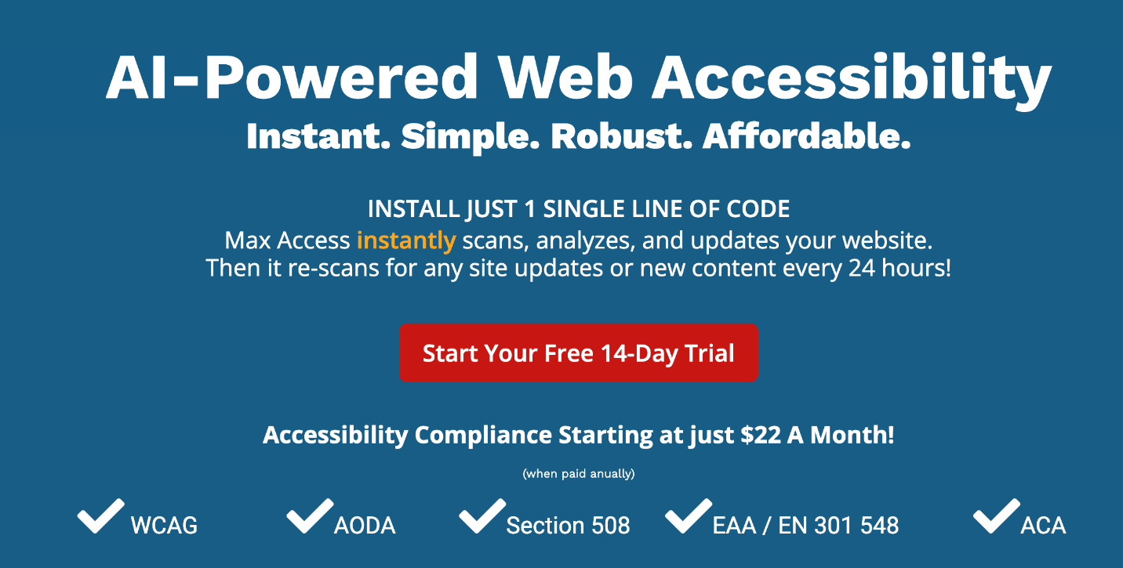
Figure 60: AI-Powered Web Accessibility

Evidence from Facebook
https://www.facebook.com/digitalaccessibilityonline/

The company claims that “Certification is the Only Accessibility Solution You’ll Ever Need,” although there is no recognized certification standard:

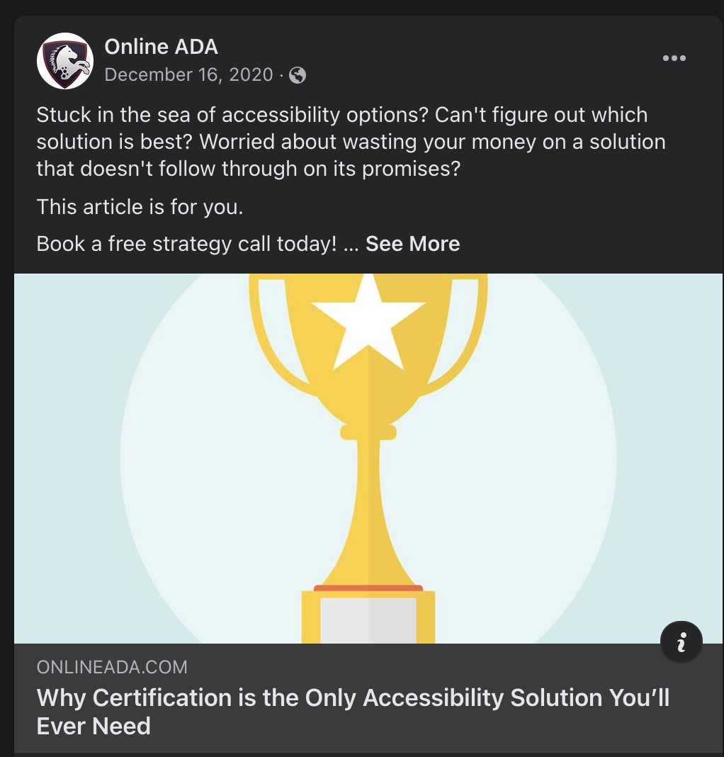
Figure 61: Why Certification is the Only Accessibility Solution You’ll Ever Need (Captured October 25, 2021)
https://www.facebook.com/digitalaccessibilityonline/posts/1974843319324858

Evidence from Google Ads (source: SpyFu.com)
OnlineADA/ MaxAccess spends an estimated $2736 on CPC ads per month.
86% of the MaxAccess.io website traffic comes from CPC ads

The company’s Google ads claim that their product offers, “Accessibility in 1 Click,” and can get your website, “Accessible in Minutes”:
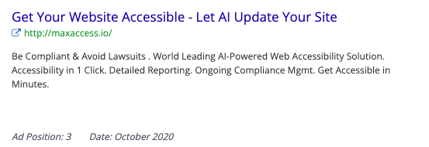
Figure 62: Get Your Website Accessible (Captured October 24, 2021)
MaxAccess uses the familiar lawsuit scare tactics in its ads:

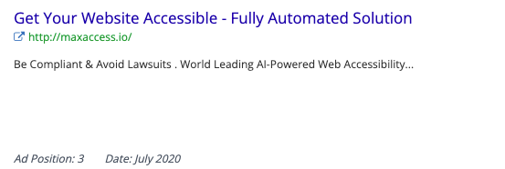
Figure 63: Fully Automated Solution
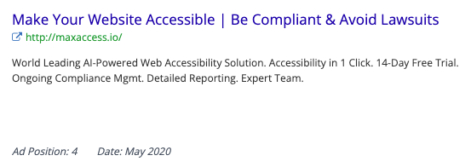
Figure 64: Be Compliant & Avoid Lawsuits

In addition to using the now all-too-familiar tactic of “protect[ing] your business from lawsuits,” this particular ad demonstrates the company’s unfamiliarity with actual accessibility by using the incorrect term “Alt-Tag”:

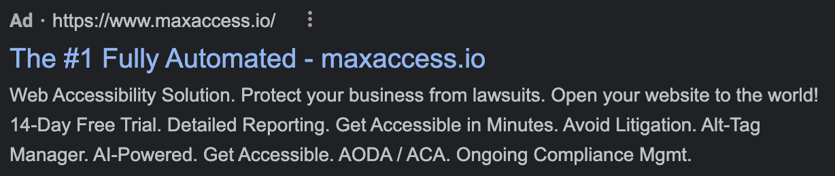
Figure 63: The #1 Fully Automated

Purple Lens
Address: Tel Aviv, Israel
Website: https://purple-lens.com

“We are a team of entrepreneurs, web-developers, UX/UI designers and physicians based in Israel. We are dedicated to finding a solution that makes websites more usable for 20% of online users in order to create equal opportunities.

For years, web accessibility has been an issue for almost any type of online business that struggled to gain new visitors and customers. A majority of sites work on WordPress and since the Israeli legal requirements for website inclusivity are particularly strict, we set a goal to make all WordPress sites accessible, whatever it takes.

We invested a huge amount of time and energy, eventually creating today’s most advanced solution. Our assistive technology has been implemented in numerous projects for the Israeli Government and multiple local businesses. Today, thousands of Israeli websites use our assistive technology and now we are ready to go global.”
(https://purple-lens.com)

Evidence from Website
The company claims that its product will allow a personalized UX for “EVERY user” (emphasis theirs) and promises “AA accessibility compliance”: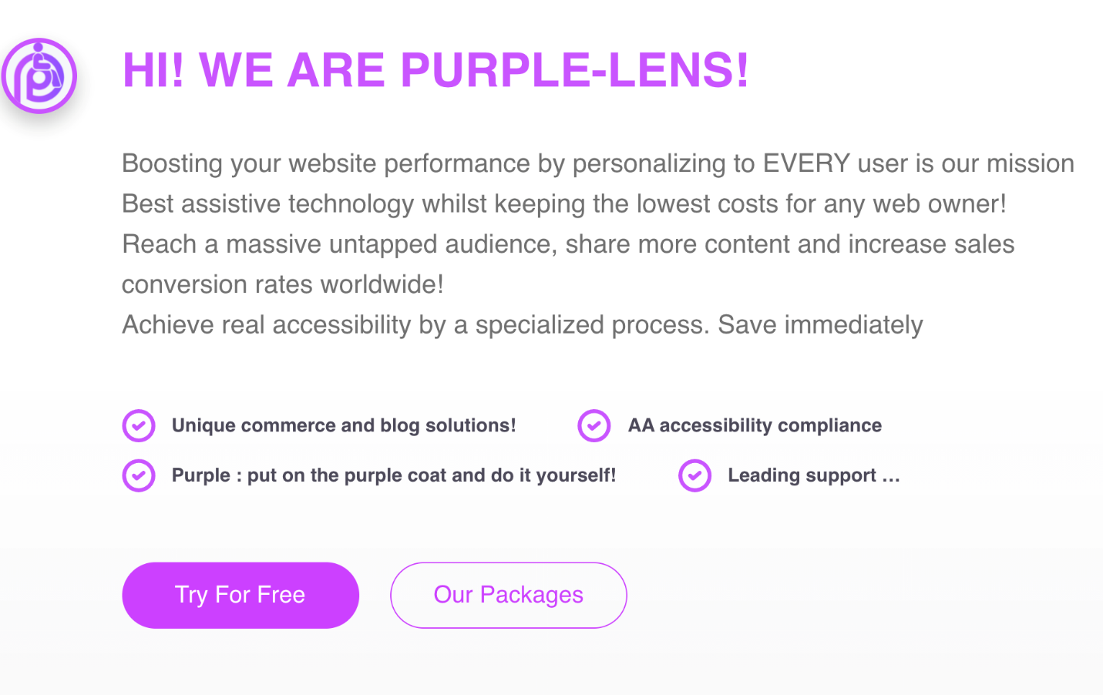
Figure 65: Hi! We are Purple Lens! (Captured October 25, 2021)

For less than $16 per month, Purple-Lens claims that their product can “Achieve 100% AA Compliance”: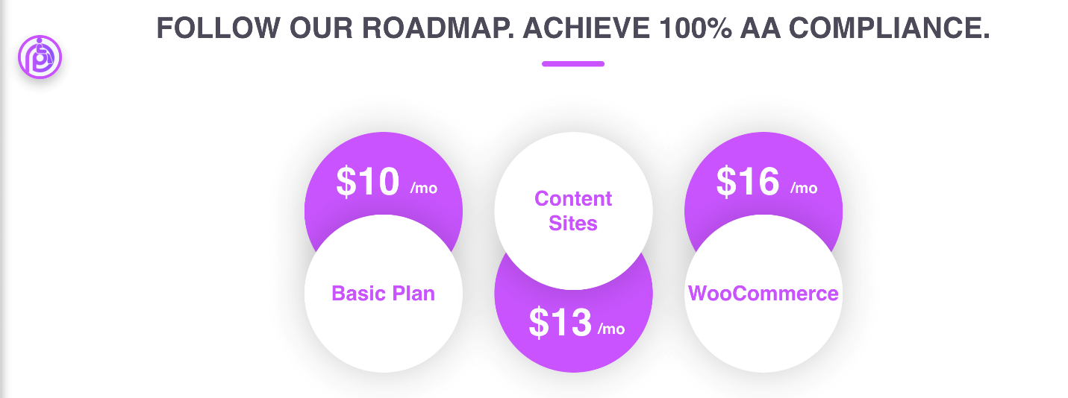
Figure 66: Follow Our Roadmap (Captured October 25, 2021)

UserWay
Address: 1007 North Orange St. 10th Floor Wilmington, DE, 1980, USA
Website: https://userway.org/

“UserWay creates advanced website accessibility solutions that help ensure ADA compliance without refactoring your website's existing code.

With UserWay's RaaS™ (Remediation as a Service™) technology you can effortlessly increase compliance with WCAG 2.1, ADA, ATAG 2.0, EN 301-549, and Section 508 regulations as required by US & international governmental & regulatory bodies.”
(https://userway.org/about/)

Evidence from Website
On its website, UserWay claims its solutions “provide full WCAG & ADA compliance from day one” and protects its clients from “accessibility-related lawsuits”:

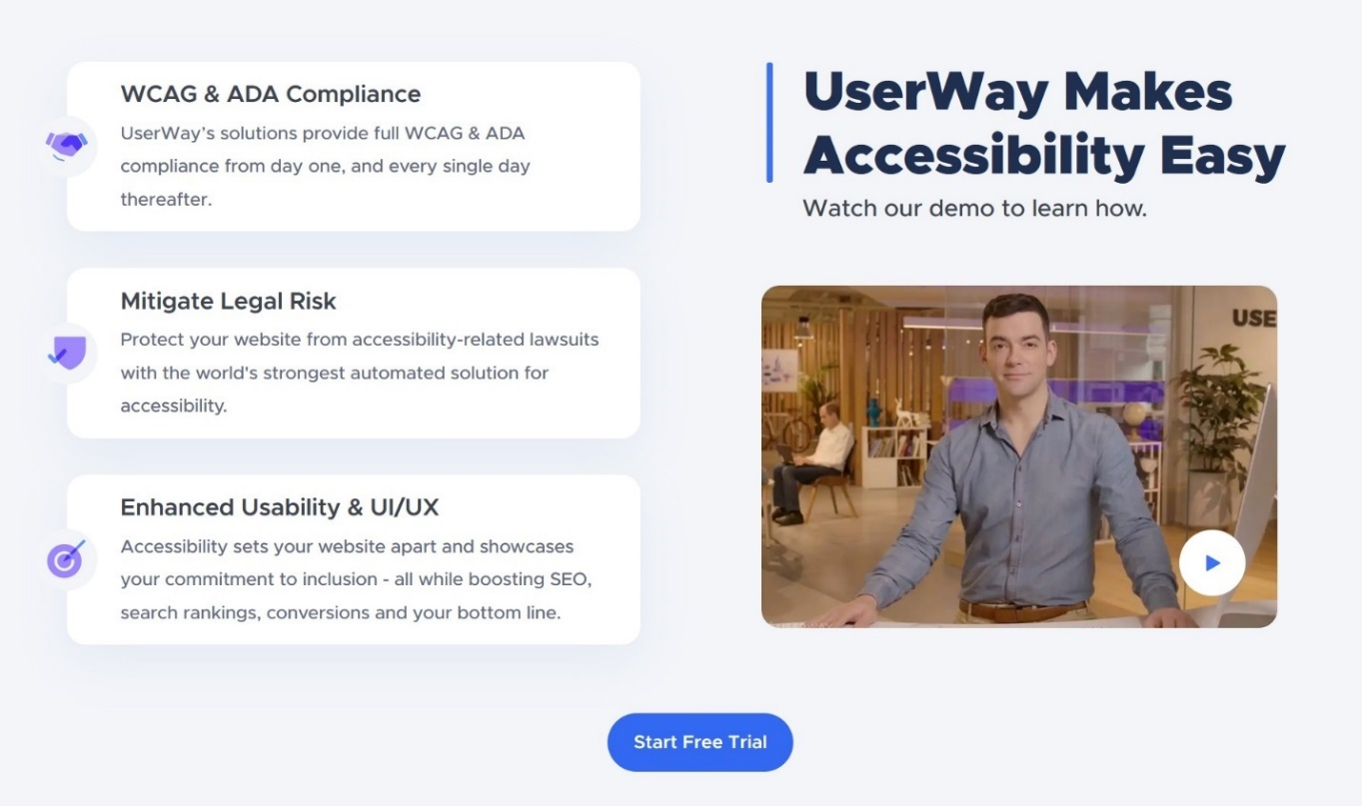
Figure 67: UserWay Makes Accessibility Easy (Captured October 24, 2021)

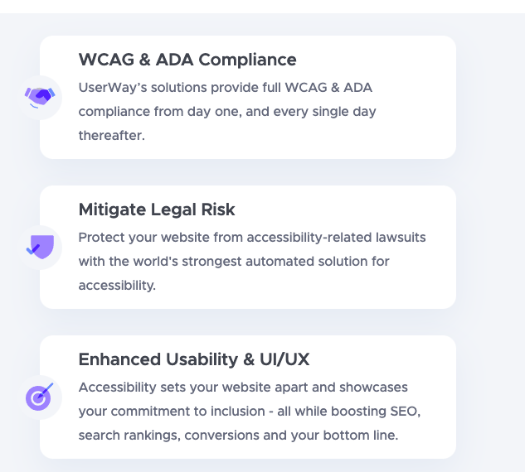
Figure 68: WCAG & ADA Compliance (Captured October 24, 2021)

The company claims its customers can “avoid lawsuits with only a single line of code” and that their solution is “[t]rusted by more than 1,421,130 websites” and is backed by a $1 million guarantee:
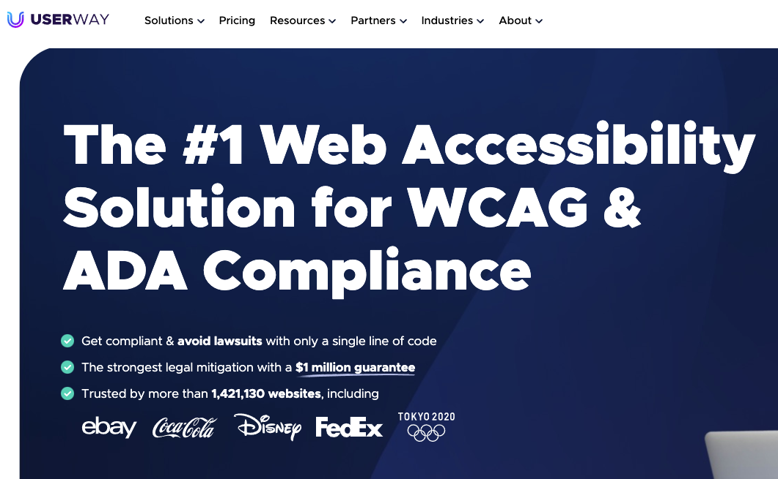
Figure 69: The #1 Web Accessibility Solution

UserWay’s website also uses the familiar legal scare tactics:
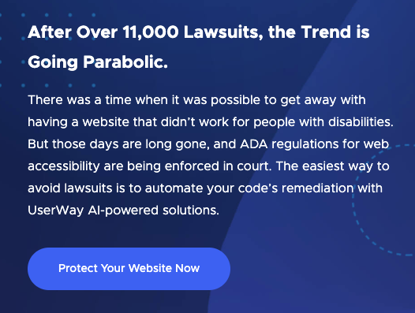
Figure 70: The Trend is Going Parabolic

The FAQ section of the website also claims the product “provides full ADA and WCAG 2.1 compliance”:
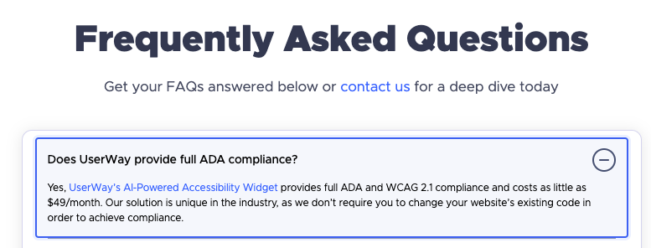
Figure 71: Does UserWay provide full ADA compliance? (Captured October 24, 2021)

The FAQ also claims that using UserWay’s widget, a client will “luckily” not need their assistance with demand letters or lawsuits (which itself seems to undermine its claims to protect against them), but in the case a client does receive such a legal challenge, UserWay will provide what we consider a legally useless “Statement of Compliance” as proof of a site’s accessibility:

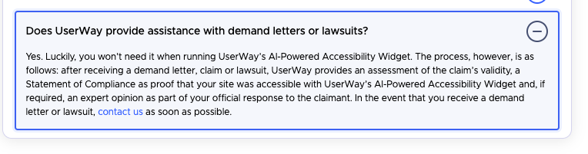
Figure 72: Does UserWay provide assistance with demand letters or lawsuits? (Captured October 24, 2021)

Evidence from Email
In their direct marketing emails, UserWay promises that their widget gives “full (emphasis theirs) WCAG coverage” and can make a site “completely ADA-compliant”:
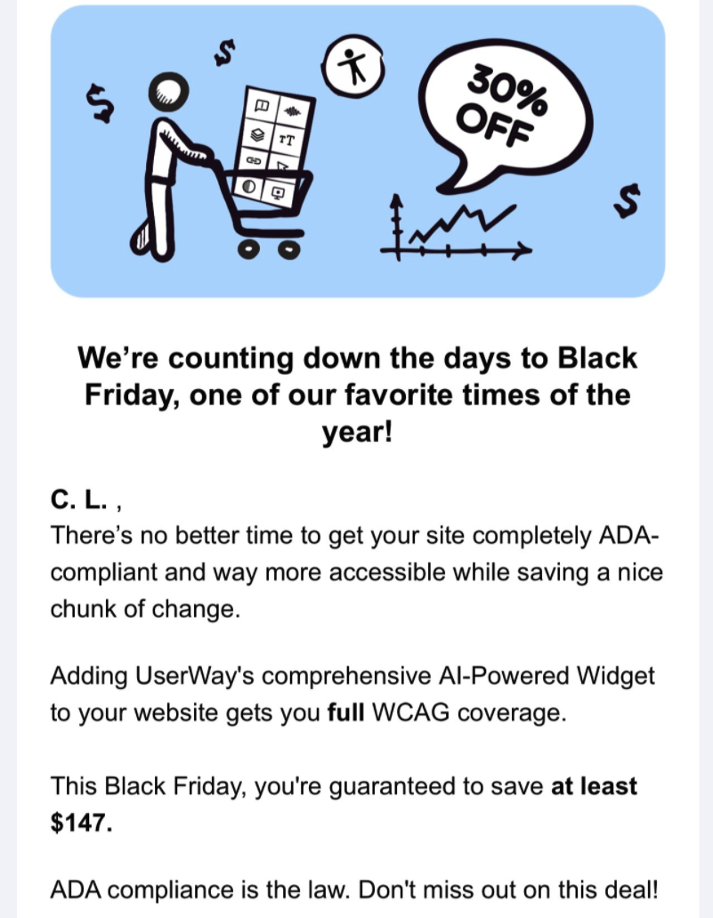

Figure 73: Black Friday Deal (received and captured November 19, 2021)

Evidence from Twitter
UserWay makes the bold claim that its screen reader is better than “standard screen readers” because it “is engineered specifically for websites”:
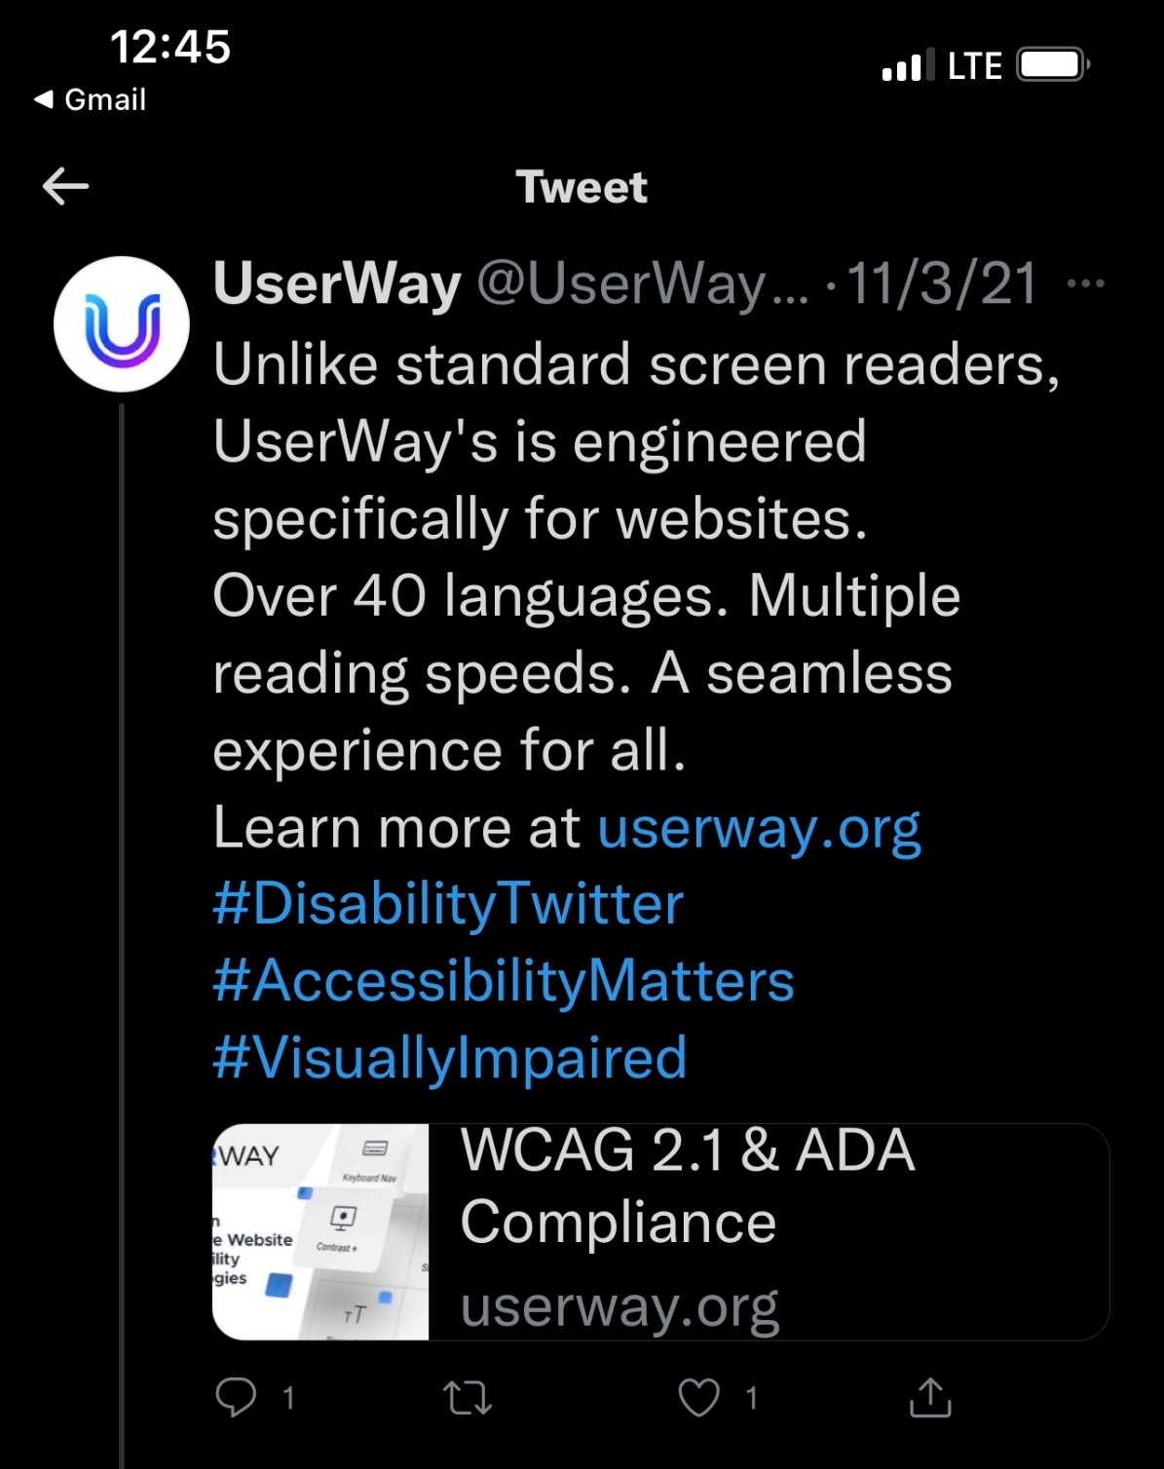
Figure 74: UserWay's Screen Reader (Captured on November 3, 2021)

Evidence from Facebook
https://www.facebook.com/UserWay

On Facebook, the company claims that it can magically make all sites compliant “in a flash”:

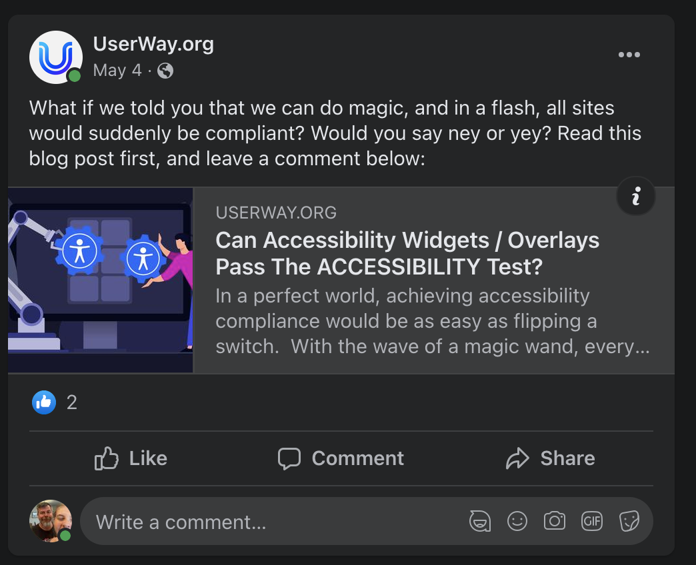
Figure 75: Can Overlays Pass the Accessibility Test? (Captured October 24, 2021)
https://www.facebook.com/UserWay/posts/2906487569592368

UserWay continues to push the “one line of code” solution as a viable one:
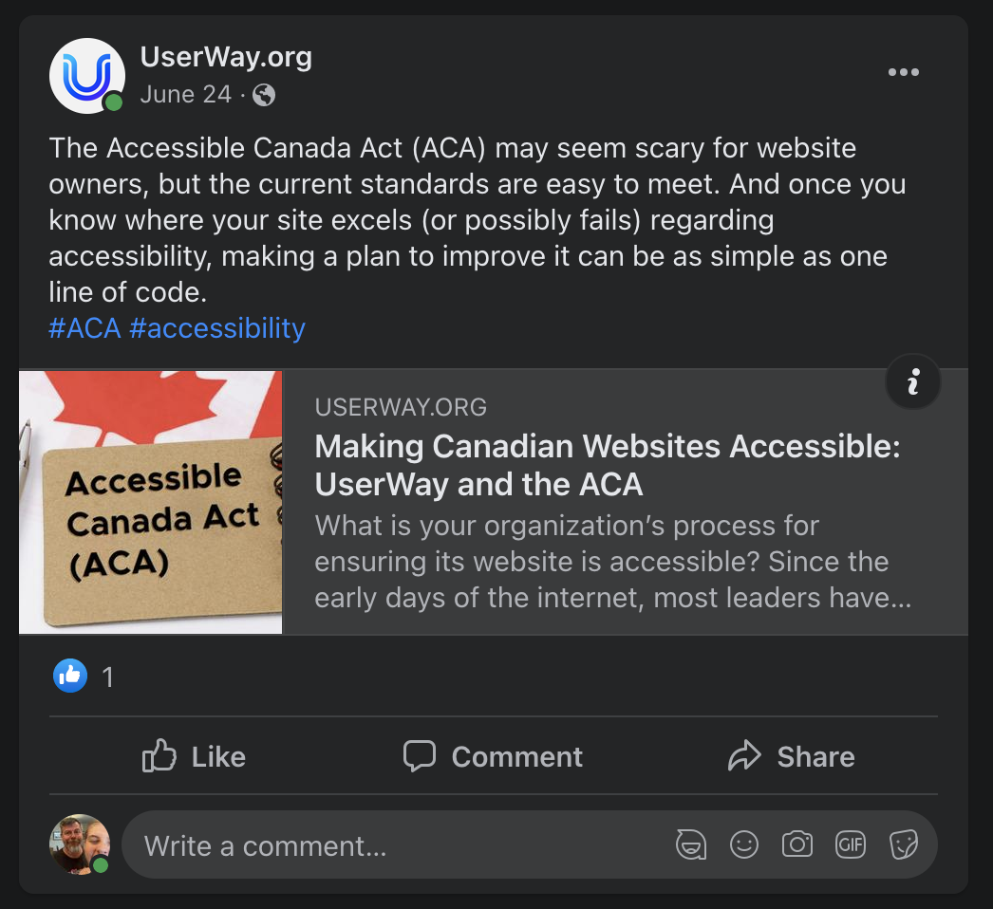
Figure 76: Accessible Canada Act
https://www.facebook.com/UserWay/posts/2942545285986596
For e-commerce platforms, the company claims that its product will make their sale prices “automatically…accessible”. Ironically, the linked video does not have an audio description so is, itself, inaccessible to screen reader users:
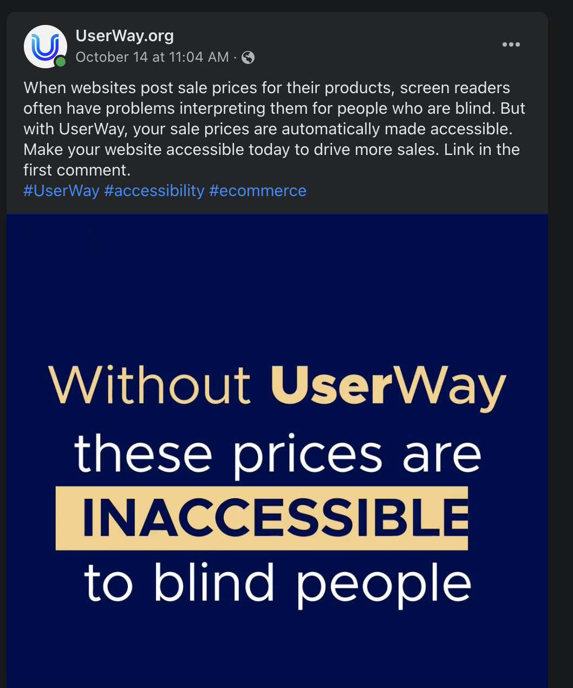
Figure 77: Sale Prices
https://www.facebook.com/UserWay/videos/295124915776001/

The company claims its product will make “all the [color contrast] customization options” with one click:
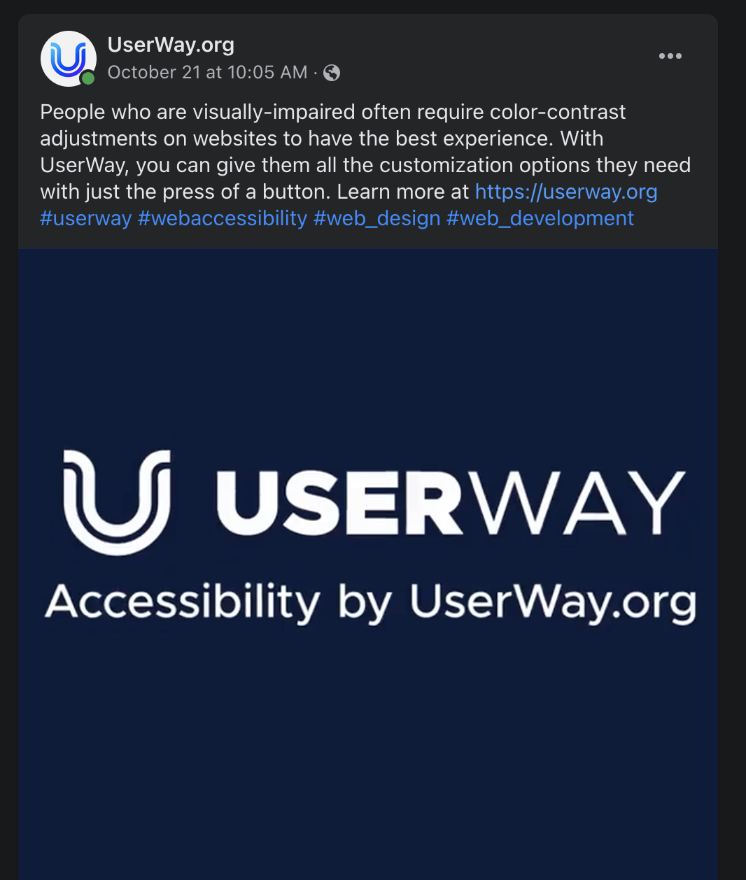
Figure 78: Color Contrast Adjustments
https://www.facebook.com/UserWay/videos/3034451863468844/

The company also claims its product can be beneficial to Shopify store owners and “ensure their shops are inclusive”:
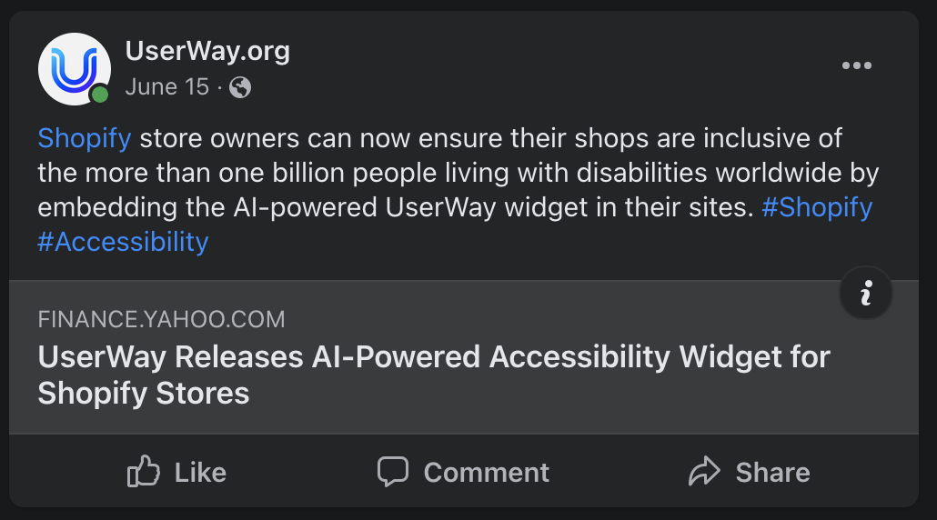
Figure 79: Shopify Widget (Captured on October 24, 2021)
https://www.facebook.com/UserWay/posts/2906487569592368

Evidence from Google Ads (source: SpyFu.com)
UserWay spends an estimated $6057 on CPC ads per month.
15% of the UserWay website traffic comes from CPC ads

On its Google Ads, UserWay claims that “ADA & WCAG 2.1 Compliance” can be achieved with “No Changes to Your Website’s Code.”

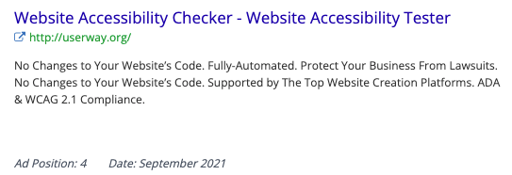
Figure 80: Google ad (Captured September 2, 2021)

These ads continue peddles the lie that “ADA & WCAG compliance” can be achieved with “[n]o changes to your website’s code”:

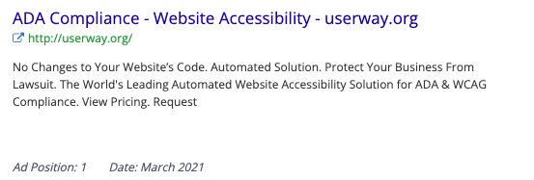
Figure 81: ADA Compliance - Website Accessibility (Captured September 2, 2021)

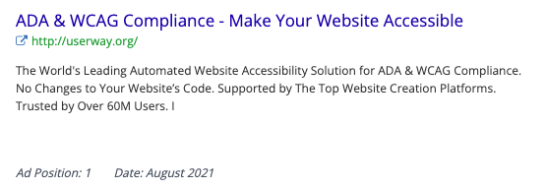
Figure 82: ADA & WCAG Compliance (Captured September 2, 2021)

The company also touts that its “powerful AI” can fix inaccessible sites automatically:

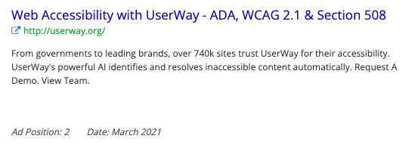
Figure 83: ADA, WCAG 2.1 & Section 508 (Captured September 2, 2021)

UserWay claims its solution can protect its clients’ “business from lawsuit[sic]” make a website “Lawsuit-Free” with the familiar “no changes to your website’s code” line:
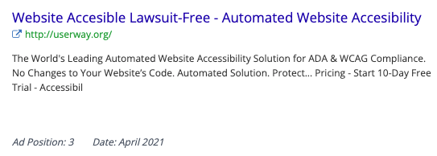
Figure 84: Lawsuit-Free (Captured September 2, 2021)

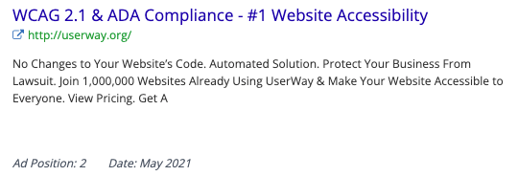
Figure 85: #1 Website Accessibility (Captured September 2, 2021)

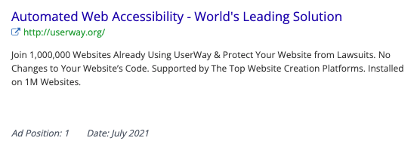
Figure 86: Automated Web Accessibility

Evidence of other anti-competitive behavior
UserWay’s widget interferes with automated web accessibility tools such as WAVE, even pointing the user to using the company’s own “UserWay Inspector” instead of whichever tool the user chooses:
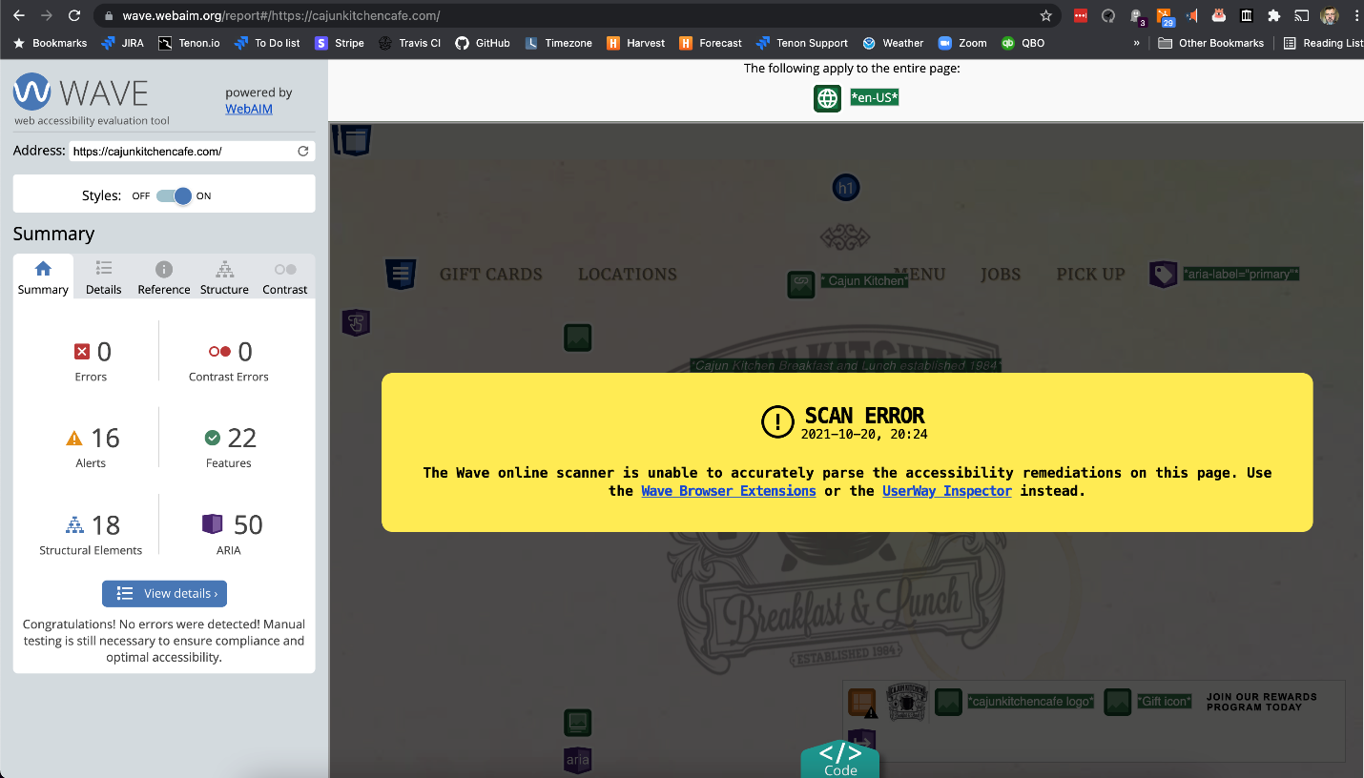
Figure 87: UserWay - WAVE Scan Error (Captured October 20, 2021)

